A Study on the Working Conditions within the Post-Consumer PET Waste Materials Flow and Recycling Value Chain in the Philippines
April 2023

Table of Contents
Table of Contents 1
Acronyms 2
List of Figures and Tables 2
Executive Summary 4
I. Introduction 9
a. Research Objectives 10
II. Methodology Overview 11
a. Methods of Study and Sources of Data 11
b. Analytical Framework 13
c. Scope of the Study and Limitations 15
III. Legal and regulatory framework 16
IV. The PET Recycling Industry: An Overview 24
a. Recovery and collection 25
b. Aggregation and segregation 27
c. Processing 30
V. Working Conditions in the PET Recycling Industry 32
a. Employment arrangements 33
b. Work hours 36
c. Wages, income, and benefits 38
d. Job security / livelihood 43
e. ​Freedom of association 44
f. Safety and health in the workplace 45
g. Child labor and child presence 46
h. Gender equality​ 47
i. Workplace security 48
j. Property rights 49
VI. Factors affecting working conditions 50
a. Supply and demand 50
b. Solid waste management practices of LGUs 50
c. Level of formality of businesses 51
d. Customer or buyer requirements 51
e. COVID-19 52
f. Other initiatives 53
VII. Conclusions and Key Points for Consideration 55
Moving Forward: Key Points for Consideration 56
VIII. References 60

Acronyms
BMBE – Barangay micro-business enterprise
CCBPI – Coca-Cola Beverages Philippines, Inc.
CENRO – City Environment and Natural Resources Office
CSR – Corporate Social Responsibility
DEI – Philippines Department of Trade and Industry
DOLE – The Philippines Department of Labor and Employment
DSQC – The Department of Sanitation of Quezon City (DSQC)
DTI - Department of Trade and Industry
EEMR – Estimated equivalent monthly rates
ILO – International Labor Organization
KII – Key informant interview
LGU – Local government unit
MMDA - Metropolitan Manila Development Authority
MRF – Material Recovery Facility
MTE – The Movement of Excluded Workers
NCR – National Capital Region
NGO – Non-Government Organization
NSWMC – The Philippines National Solid Waste Management Commission
NWPC - National Wages and Productivity Commission
OSH – Occupational Safety and Health
Pag-IBIG/HDMF - Home Development Mutual Fund, commonly known as Pag-IBIG
PB – Plastic Bank
PET – Polyethylene Terephthalate
PhilHealth – Philippine Health Insurance Corporation
PhP – Philippine Peso
PPE – Personal Protective Equipment
RPET – Recycled PET
SCoC - Supplier Code of Conduct
SSS – Social Security System
UNGP - UN Guiding Principles
USD – United States Dollar

List of Figures and Tables
Tables
Table 1. Summary of Interviews of Value Chain Actors
Table 2. Summary of Interviews of Other Stakeholders
Table 3. Summary of Interviews by Location
Table 4. Legal minimum wage rates per day in the National Capital Region
Table 5. Estimated equivalent monthly rates in the National Capital Region
Table 6. Recycling activities by type of worker
Table 7. Recycling worker positions categorized by level of formality
Table 8. Overview of Working Hours and Wages by Worker Category
Table 9. Wage rates for drivers and paleros in Quezon City
Table 10. Comparison of earnings of drivers and helpers in Quezon City and Las Piñas
Table 11. Comparison of employment characteristics of actors in PET value chain

Figures
Figure 1. PET bottles in one of the junk shops visited for this research
Figure 2. Map of areas included in research in Metro Manila and nearby provinces
Figure 3. Stakeholders in the PET waste value chain in Metro Manila
Figure 4. Waste collection
Figure 5. Process flow for PET processing at junk shops
Figure 6. The personnel complement of junk shops
Figure 7. Normal operating hours of junk shops surveyed
Figure 8. Average buying price per kilo of PET bottles
Figure 9. Average daily wages of junk shop workers
Figure 10: Workers in a woman-owned junkshop with all women workers

Executive Summary
This study inquired into the current state of PET recycling in the Philippines, with a particular focus on the areas of Metro Manila and its neighboring provinces of Cavite and Rizal. It provides a snapshot of the supply chain, the various supply chain actors, and the different categories of workers and the conditions that characterize workplaces; and explores the potential solutions to improve the situation of the workers in the sector.

It sought to document and analyze the drivers and root causes of the labor conditions of workers in the PET recycling in the Philippines, and to flag other risk sources that impact the vulnerability of workers across the chain.

Methodology

The study focused on the PET recycling supply chain and involved collecting data from various sources, including workers, business owners and managers of the different tiers in the recycling supply chain. Representatives of relevant government offices and industry associations were also interviewed. Data collected from primary sources were complemented by desk research and a review of the legal and regulatory framework. A dedicated chapter provides an overview of the legal and regulatory environment governing the PET recycling industry. It explains the different laws, regulations, and standards that apply to PET recycling, and discusses their impact on the industry.

Data from both primary and secondary sources were analyzed using both quantitative and qualitative methods to identify key trends and challenges in the PET recycling industry. Despite the limitations, the methodology allowed for comprehensive and in-depth mapping and analysis of the working conditions in the PET recycling supply chain.

Highlights / Key Research Findings

The report found that the recycling industry faces significant challenges in ensuring safe and fair working conditions for its workers. It showed that working conditions in the PET recycling sector are generally poor and characterized by various health and safety hazards, with widespread employment arrangements and practices that exacerbate workers’ vulnerability to a host of human rights issues.

Most workers in the PET recycling sector were employed under precarious arrangements, such as temporary contracts or self-employment. This was especially true for workers in the informal sector such as the collectors and waste pickers, junkshop workers, and garbage collectors, who often lacked any formal employment contracts or legal protections. They also typically worked long hours, with some working up to 14 hours per day, often without adequate breaks or rest periods. Additionally, the wages of workers in the recycling sector were generally low, with many workers earning less than minimum wage. This was especially true for workers in the informal sector, who often earned less than those in the formal sector and lacked access to benefits such as health insurance and pensions.

Other key findings that are worth highlighting are the following:

- There were significant differences in the conditions of employment tied to how the workers were recruited and contracted for their jobs, and these conditions were closely linked to the level of formality or informality of the arrangements and the operations they were involved in.
  - The study found that no employment contracts were signed between junk shop owners and workers, which meant that workers could leave at any time they wanted. However, this lack of a formal agreement also meant that the workers had no legal protection or job security and were vulnerable to exploitation or abuse. Without a contract, workers face challenges in asserting their rights or seeking compensation or remediation for any grievances they may have against their employers.
  - Aside from junkshop workers and waste pickers and collector, other types of workers in the supply chain such as garbage truck drivers and helpers employed by private companies or local governments, MRF workers, or workers in processing facilities, had contracts in place. However, despite this, some workers were still vulnerable to labor abuses, especially when the terms and conditions of their contracts do not comply with labor laws. These workers were found to have inadequate social benefits and low wages (that often did not meet the legal minimum wage), leaving them struggling to make ends meet. Workers who faced this particular challenge were garbage truck drivers and helpers.

- The majority (80%) of the workers interviewed reported working more than 8 hours a day, closer to 10 to 11 hours per day or a total of about 60 to 66 hours per week, including breaks.
  - This risk is particularly evident among junkshop workers and garbage truck drivers and helpers.
  - Junk shop workers follow their junkshops operating schedules. This schedule translates to rendering 10 to 11 hours per day, and about 60 to 66 total hours per week, inclusive of breaks.
  - Junk shop drivers' working hours are difficult to predict and control, as they are heavily influenced by traffic conditions in Metro Manila, as well as potentially long waiting times at recycling facilities. On the other hand, garbage truck drivers and helpers employed by government and private contractors have more defined working hours, but they are also at risk of working excessive hours.
  - There is also a lack of a systematic mechanism to monitor work hours in the aggregation tier, specifically in junkshops.
  - Workers in material recycling facilities and in processing facilities, on the other hand, given the more formal nature of their work, followed a stricter work schedule.
  - Collection workers reported that they need to spend at least 5 to 10 hours daily collecting recyclables in order to make a significant earning.

- Wages in the collection and aggregation tiers of the supply chain tend to be lower, primarily because of the high concentration of informal actors in these processes. The research identified that this was particularly true for certain types of workers, including piece-rate junkshop workers responsible for cleaning PETs and helpers at garbage haulers. The study also found that truck drivers, whether working in junkshops or for garbage hauling companies, were more likely to receive wages that were at or above the minimum wage, whereas their helpers (or "paleros") typically earned below the legal rate.
  - Workers in junkshops in Quezon City, Makati City, and Marikina City were found to receive the highest wages, but still, many don’t meet the minimum wage. Of the 26 junk shops that were visited, only five (5) were found to provide wages that are on a par with or higher than the applicable legal minimum wages rates, which are PhP570.00 (US$9.64) in the National Capital Region and PhP435.00¹ (US$7.36) in the Cavite province. On the other hand, junkshop workers in the City of Manila receive the lowest daily wage with the average of PhP250.00 (US$4.23) based on the sampled junkshops.
  - PET cleaners earned less than most regular junkshop workers, with an average of PhP3.00 (US$0.05) per kilo of the cleaned and sorted PET bottles. To increase their income to at least PhP250.00 (US$4.23) a week, some PET cleaners prefer to have their bottles weighed weekly instead of daily.

- Social welfare benefits were provided to only a few workers in the supply chain.
  - Benefits like paid vacation, sick, and maternity leaves as well as the annual 13th month pay were provided to recycling facility workers. The employer also paid for workers’ SSS, PhilHealth, and PAG-IBIG funds.
  - Garbage truck haulers employed by both government and private companies were registered to the SSS, PhilHealth, and PAG-IBIG as self-employed (without employers’ counterpart contribution), and their employers merely assisted in filing and paying for these benefits by automatically deducting monthly premiums from their salary.
  - Only one junkshop interviewed, located in Makati City, provided employer contribution for their workers’ SSS, PhilHealth, and PAG-IBIG funds, and pays their workers minimum wage.

- Junk shops tend to assign job roles based on gender, with men workers often assigned to more physically demanding tasks such as lifting heavy recyclable waste and delivery, while female workers are typically assigned to tasks such as sorting and cleaning PETs. Women personnel are also often preferred for cashiering and shop managing.
  - Researchers found that this gender-based assignment of job roles can reinforce stereotypes and lead to unequal treatment and opportunities for workers based on their gender. Furthermore, this practice can result in gender-based wage disparities, such as delivery truck drivers, who are mostly men, receiving higher wages compared to PET cleaners, who are mostly women and receive lower wages.
  - In the province of Cavite, there is a woman-owned and an all-women operated junkshop where the women workers perform tasks typically associated with men, such as driving the delivery truck and lifting or moving heavy materials. This challenges traditional gender roles and stereotypes often present in the junkshop industry.

- During the research interviews and visits, child or young waste pickers were observed to be selling recyclable waste to junkshops. Despite efforts by some junkshops to prohibit such transactions, it was difficult to restrain children and young persons from transacting with them because this provides a means of earning or augmenting their families’ income, especially for those living on the streets. Also, some junk shops were managed by stay-in families who may have children helping out in operations.

- Most junk shop owners leased the space for their business since they could not afford to build their own shops because of the expensive land and material costs. Moreover, small-scale junk shop owners often operate from their homes to minimize operational costs. These resource-related challenges often faced by junkshops may hinder their ability to provide better wages and benefits, and other social and H&S protections, to their workers, especially without any industry-wide changes or support from their buyers.

It is worth noting, moreover, that in terms of supply chain monitoring, there were limited transparency and traceability mechanisms, and still-undefined accountability among various actors in the PET recycling supply chain. The research team found almost no traces of a process to cascade\ information on social and labor standards, or any resources and support for lower-tier supply chain actors to understand and implement these standards, from the part of their buyers, all the way to the processing facilities where their products end up in and which form part of a larger, global supply chain.

Moving Forward: Key Points for Consideration

The recommendations or key points for consideration presented in this report are developed in response to these complex issues faced by the workers and the different stakeholders in the PET recycling sector.

- A strategic, collaborative, and multi-stakeholder approach is necessary.

Given the complexity and the systemic nature of some of the issues, and the wide gamut of actions that must be taken to address them, there is a need for increased collaboration and coordination among various actors. Solutions may be best approached as a multi-stakeholder effort that takes into account the specific needs and vulnerabilities of the workers, the limited capacity and capabilities of small and informally-organized businesses, the legal and regulatory environment; and the resources, accountability, and responsibility of downstream supply chain actors.

Specifically, Verité puts forward the following recommendations for consideration of a multi-stakeholder initiative:

- Develop a governance structure for the multi-stakeholder initiative and determine the roles and responsibilities of participating stakeholders;
- Develop a general set of standards on human rights and labor rights in the PET value chain in particular, and recycling sector in general, which is consistent with existing legal and regulatory framework and attuned to the circumstances of the various tiers in the sector;
- Develop and implement adequate, effective, and sustainable programs and projects in support of and to ensure compliance with the general set of standards across the PET value chain / recycling sector. Incorporate communication and training programs for the PET value chain / recycling sector in general; and monitoring systems, which include risk assessment and management, audits and assessments, and corrective and preventive action management, as well as monitoring for improvement.

- Supply chain compliance and monitoring mechanisms should be strengthened.

Regardless of whether a multistakeholder platform or organization is established, specific steps and actions are offered for consideration by buyers/customers sourcing recycled materials from the Philippines and countries (where the conditions are the same), and processors in the PET value chain. Coca-Cola Beverages Philippines, Inc. (CCBPI) is in a strategic position to carry out such specific steps and actions independent of multi-stakeholder efforts described in No. 1. ​

In addition, buyers, such as CCBPI, can consider the following key action points:

- Establish and communicate written policy commitments specifically to minimize and address adverse impacts on workers in the PET recycling sector, which adhere to international legislations and customer requirements;

- Embed these commitments not just in the programs of sustainability and human rights departments, but also in sourcing and procurement, supplier selection, and other business units;

- Prioritize specific issues – among the ones identified in the report – and develop clear targets, making them a basis for the development of practical and results-oriented programs that can be implemented in cooperation with other stakeholders;

- Develop and implement a compliance program in support of said commitments (for labor and human rights) for PET supply chain actors, or review and revise existing compliance programs to include said actors within their scope, with such programs consisting of the following components, among others:
  - Risk assessment and management;
  - Audits and assessments;
  - Corrective and preventive action management;
  - Monitoring for improvement and effectiveness.

- Clearly communicate these commitments and requirements to supply chain actors, and initiate capacity-building and support programs to ensure everyone in the supply chain understands and implements the requirements;

- Develop and implement strategies and schemes to ensure that PET supply chain actors remain in business relationships within the chain, while concurrently ensuring compliance with applicable standards on labor / human rights:
  - Pricing mechanisms may be reviewed, and incentive programs implemented (e.g., premiums on sustainable products are provided as an incentive for compliance);
  - Higher tier / formal processing facilities can be capacitated to implement supplier management and monitoring programs, to ensure all operations and production processes across the value chain are sustainable and meet legal and customer requirements;
  - Lower-tier supplier facilities and work sites (e.g., junk shops) can be included in capacity-building programs designed specifically to address the most salient issues in their operations.

Sustainability, supplier engagement, procurement, legal and social compliance, and other related functional units are the key business units for these action points.

- Other key actors must be involved.
The responsibility to address these challenges, and work towards creating more just and equitable workplaces, and ensure the long-term sustainability of PET recycling in the Philippines, need not fall solely on the shoulders of the private sector.
Other actions for consideration by government and civil society stakeholders are forwarded as well, such as incorporating human rights and labor rights in the solid waste management system; and providing assistance and support (e.g., training), notably to the most vulnerable actors in the PET value chain.

Verité also highlights that there is already much to learn from multi-stakeholder initiatives in other sectors, such as seafood/fishing, palm oil, cocoa/chocolate, and cotton industries. Top players like The Coca-Cola Company can align with their peers on standards and commitments to ensure that PET recycling and informal workers are protected and recognized by regulatory frameworks, and that they do not remain at the fringes of society and the economy.

To share questions or comments about the report, please email Verité Southeast Asia at: vsea@verite.org. ​

Introduction
Polyethylene terephthalate or PET is one of the most valuable types of plastic in the Philippines and the most retrieved due to their high residual value and predicted value post-consumption. They are commonly used in bottles and other plastic containers for food and beverages, and they can be re-used and transformed into many different products through the process of recycling. Recycled PET (RPET) is one of the most widely used recycled plastic across the globe. Recycled PET has been used for various applications such as fiber for carpets, clothes, upholstery, sweaters; fiber-fill for sleeping bags and cushions; sheet and film; and automotive parts. One of the key emerging applications of RPET is in food packaging (e.g., food-grade bottles and containers). The demand for RPET is supported by the fact that RPET offers performance similar to that of unrecycled or virgin PET. The level of interest in PET recycling has soared in recent years and is expected to grow at a 5.7 percent compounded annual growth rate from 2021 to 2026, leading to projected reach of 11.6 million U.S. dollars by 2026.
The Philippines has one of the highest PET bottle recovery rates at 90 percent, according to a study conducted by the global advocacy firm McKinsey Center for Business and Environment. Metro Manila has one of the highest plastic waste densities in the world, as evidenced by the high concentration of recycling activities and the presence of several significant PET recycling players in the metropolis alone.
Figure 1. PET bottles in one of the junk shops visited for this research.
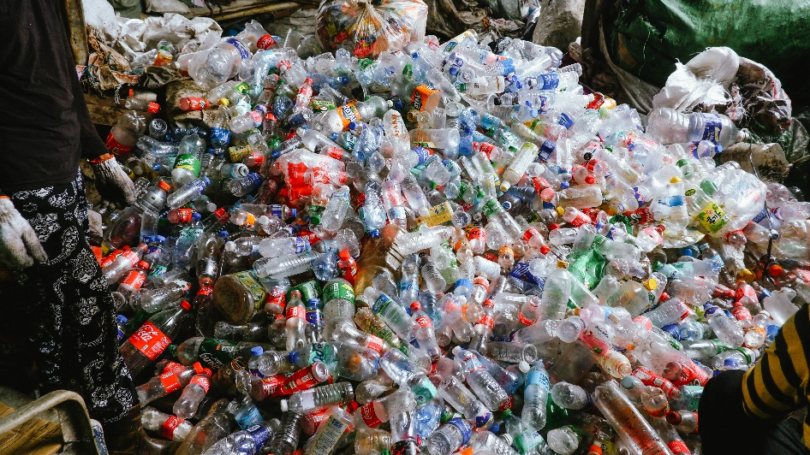

These various players involved in the recycling of PETs generate local job and income opportunities. However, employment arrangements are often informal, irregular, and short-term, leading to precarity. The general nature of work in the solid waste and recycling industries is also characterized by poor and hazardous working conditions. For many informal workers with already very limited social mobility, exposure to poor working conditions is compounded by the absence of labor relationships leaving them highly vulnerable, unprotected by legal frameworks, unable to access social protections, and thus trapped in multi-generational poverty. For those workers where formal labor relationships may be in place, there still remain some significant challenges when it comes to exercising basic labor rights and having decent working conditions. he opportunities for growth, upskilling, and overall welfare development remain low for workers in the recycling industry.
With the increasing demand for recycled PETs and the expansion of PET recycling activities comes increased interest in the impact of business operations on people. The need to understand the situation of workers in the industry becomes ever more imperative to ensure that these workers are not left behind and that they access economic and social benefits of PET recycling. Doing so also presents an opportunity for various business, government, and civil society stakeholders to address the sources of workers’ vulnerability, and the root causes and systemic nature of many of these issues that workers in the recycling industry are exposed to.

Research Objectives
Acknowledging the complexity of risks and intersections of issues faced by workers in the PET recycling industry, Verité conducted a qualitative research to document and analyze the drivers and root causes of the labor conditions of workers in the PET / plastic waste value chain, recycling and waste management practices, and to flag other risk sources that impact the vulnerability of workers across the chain.
The main objective of the research is to gain a comprehensive understanding of the labor practices and related production processes and systems in the post-consumer PET recycling value chain, and how these impact the promotion and protection of the rights of workers, and the ability of industry players to comply with core labor standards and requirements.
The research was guided by the following key research questions:
- What human rights and labor rights issues are most pervasive in the PET / plastic waste recycling sector?
- What human rights and labor rights issues are common across the sector or unique to specific categories of workers?
- What are the key drivers or root causes of these issues, and what policies and programs have been put in place to address them?
- What are the challenges faced by the PET / plastic waste recycling industry in applying and adopting labor standards?

The study intends to provide useful information and insights on the unique risks to workers presented by PET recycling, upon which more deliberate and focused set of programs and interventions may be developed to protect the rights and promote the welfare of workers.

Methodology Overview

Methods of Study and Sources of Data
This study employed a descriptive survey design to assess the conditions of workers in the post-consumer PET waste value chain in Metro Manila, with a focus on determining labor and human rights issues and risks. Data-gathering activities commenced in December 2021 and concluded in February 2023.
The research began with a preliminary scoping of issues in order to prioritize areas of concern, which was conducted through desk research. Research involved the review and analysis of relevant information from a wide variety of sources including reports, research studies, and media articles, among others. The scoping stage was also guided by previous work conducted by Verité in the recycling sector, specifically in Indonesia, the Philippines, and in Latin America.
The research team then began primary data collection through in-person and remote key informant interviews (KII). These were conducted in a semi-structured manner to facilitate the gathering of mainly qualitative data on the priority areas of concern. Researchers used open-ended questions to ensure that the most relevant information from the interviews could surface. Interviews with workers allowed contextual information to be gathered on the specific risks faced by different types of workers in the supply chain.
The flexible approach was critical to researchers’ ability to gather data effectively, especially in locations such as streets and junk shops, to discuss the overall precariousness of workers’ employment and working conditions. Data gathered from interviews with workers and business owners were triangulated with desk research and expert informant interviews to illuminate trends influencing key issues and vulnerabilities identified.
Figure 2. Map of areas included in research in Metro Manila and nearby provinces
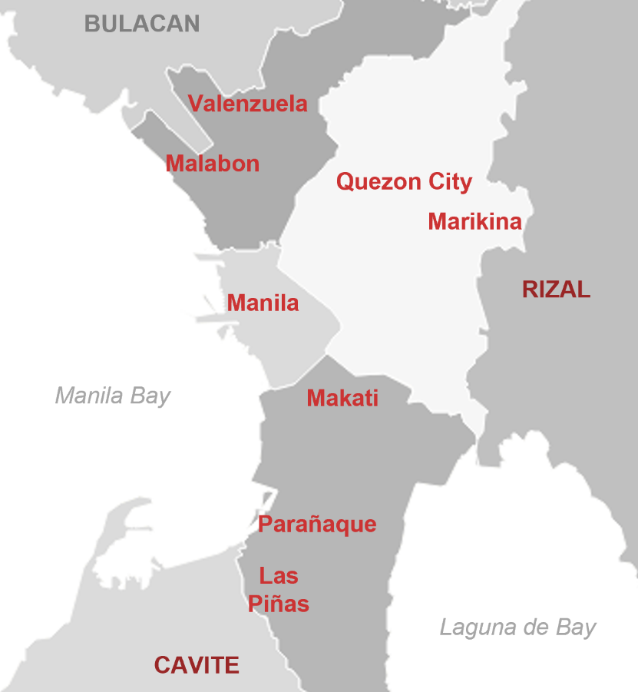

The geographical scope of the research is within Metro Manila. Due to time and resources limitations in data gathering, the researchers only visited eight (8) of these 16 locations, namely: Manila, Quezon, Las Piñas, Parañaque, Marikina, Valenzuela, Makati, and Malabon. The nearby provinces of Rizal and Cavite were subsequently added as additional focus areas.
Verité interviewed workers from various recycling tiers as the main respondents in these cities in Metro Manila, with additional information gathered from business owners and managers, industry associations, national and local government representatives, nongovernment organizations (NGOs), and other key stakeholders. Although researchers did not have the opportunity to visit the city of Navotas, a remote KII was conducted to gather information about practices in the Navotas Sanitary Landfill. Respondents, especially the workers, were purposively sampled to represent a wide cross-section of work processes and tiers. A total of 73 key informants were interviewed for this study.
As shown in Table 1 below, interviews covered 36 male and 22 female respondents who worked at different tiers of the recycling supply chain. Researchers interviewed seven (7) waste pickers/collectors/eco-aides, 16 junk shop owners, 16 junk shop workers, five (5) garbage hauling drivers, and seven (7) paleros / pahinantes. Also interviewed were personnel from three (3) material recovery facilities (MRFs) which are situated in three of the focus areas in Metro Manila, as well as three (3) management personnel from a processor in Cavite.
Table 1. Summary of Interviews of Value Chain Actors
Stakeholder | Total No. of Respondents | Women | Men
Waste collectors/pickers | 7 | 3 | 4
Junk shop owners | 16 | 8 | 8
Junk shop workers | 16 | 8 | 8
Drivers | 5 |  | 5
Paleros / pahinantes | 7 |  | 7
Material recovery facilities (MRFs) | 3 | 3
Processors (workers) | 1 |  | 1
Processors (management) | 3 |  | 3
Total | 58 | 22 | 36

KIIs were also conducted with stakeholders from industry associations, sanitary landfills, national and local government agencies, and non-governmental organizations.
Table 2. Summary of Interviews of Other Stakeholders
Stakeholder | Total No. of Respondents
Industry Associations | 5
Sanitary Landfills | 1
NGOs | 2
Government (national) | 3
Government (local) | 4
Total | 15

The ages of worker-interviewees ranged from 20 to 70 years old. During most of the interviews, there were no child workers or minors present at the sites and none of them were included in the interviews. This, however, is not indicative of the incidence of child labor and presence of children in various worksites. Workers and business owners interviewed reported the involvement of child labor and minors in the sector, and the presence of children in hazardous locations. Researchers’ physical observations and informal inspections of various worksites also confirmed the interview findings regarding child labor and child presence. In a few instances, in visits to junk shops and during interviews with owners and workers, children or young waste pickers were observed to be selling recyclable waste to junk shops while interviews for this research were being conducted. (See section of Child Labor and Child Presence).
The tools used for the interviews with workers and other stakeholders contained closed and open-ended questions that were of quantitative and qualitative in nature, but mostly of the latter, focusing on: forced labor indicators, employment age, safety and health in the workplace, livelihood and production processes, work hours, wages, benefits, gender equality, land rights, and freedom of association. For interviews with business owners and managers, additional topics were also covered, including questions that helped the research team in acquiring a better understanding of the business relationships among the different actors and players in the supply chain.
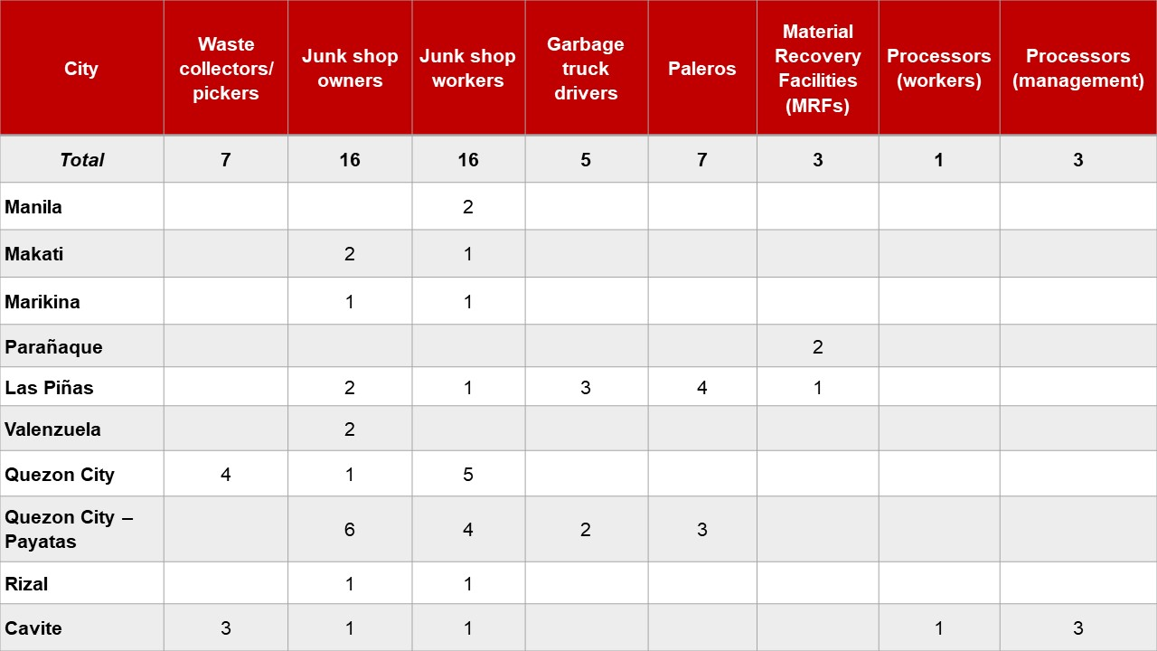
Table 3. Summary of Interviews by Location

Analytical Framework
According to the UN Guiding Principles on Business and Human Rights (UNGP), “Business enterprises should respect human rights. This means that they should avoid infringing on the human rights of others and should address adverse human rights impacts with which they are involved.” The UNGP further states that human rights refer to “internationally recognized human rights – understood, at a minimum, as those expressed in the International Bill of Human Rights and the principles concerning fundamental rights set out in the International Labour Organization’s Declaration on Fundamental Principles and Rights at Work.”
Since the study is focused on workers in the sector, the researchers thus relied on the framework provided by the International Labor Organization’s (ILO) Declaration on Fundamental Principles and Rights at Work In developing the data collection tools and in subsequent analysis of findings. These include:
- Freedom of association and the effective recognition of the right to collective bargaining;
- The elimination of all forms of forced or compulsory labour;
- The effective abolition of child labour;
- The elimination of discrimination in respect of employment and occupation; and
- A safe and healthy working environment.

Moreover, this research is anchored on ILO’s recognition of the critical importance of establishing humane conditions of work for sustainable and peaceful societies. As the ILO states:
People aspire to have not just a job but a good job. Wages, working time, work organization and conditions of work, arrangements to balance working life and the demands of family and life outside work, non-discrimination and protection from harassment and violence at work are core elements of the employment relationship and of workers’ protection, and also affect economic performance. Working conditions cover a broad range of topics and issues, from working time (hours of work, rest periods, and work schedules) to remuneration, as well as the physical conditions and mental demands that exist in the workplace.

Recognition and implementation of international labor standards are an essential component in ensuring that the growth of the global economy and global supply chains results in benefits for all, which, for the plastic recycling industry, remains to be a challenge, especially where informally employed are concerned.

Following the ILO’s guidance on what constitutes decent work, this research identified the following salient human rights risks – priority areas of concern and thematic topics critical to the post-consumer waste materials flow and in PET recycling:
- Conditions of employment
- Work hours
- Wages, income, and benefits
- Job security/livelihood
- Freedom of association
- Safety and health in the workplace
- Child labor and child presence
- Gender equality
- Workplace security
- Property rights

With regard to employment conditions, researchers examined the practices and processes surrounding the recruitment and hiring of workers, as well as the implementation of standards on work hours, wage payment, and other social benefits. Local regulations and standards around these are discussed in detail in the succeeding sections. The report also flags other concerns, such as those around child labor, gender inequality, and challenges around land rights and water resources, as these affect the operations of the industry players and, in turn, of workers.
The research also anchors heavily on frameworks that have been used to analyze labor standards as they apply to the informal economy, in recognition of its role and contribution to the recovery of post-consumer waste in cities in the developing world, including in Metro Manila. These informal ecosystems consist of independent, self-employed small-scale producers and distributors of goods and services, according to the ILO. They include individuals, families, worker groups, and small enterprises carrying out waste management activities on a full- or part-time basis, who typically lack social and economic security as well as formal recognition by government agencies. Because workers in the informal economy are for the most part not covered by countries’ labor laws and regulations, understanding their issues and vulnerabilities is central to the research.
The informal economy is a major source of employment and livelihoods in many countries and interacts closely with the formal economy. Its role especially in urban centers like Metro Manila is shown in its contribution to reducing the volume of waste through recycling activities; therefore, understanding the informal sector is important in any discussion about recycling. Informal workers are everywhere but, often, they fall through the cracks of social protection and are vulnerable to crises and disruptions. In this paper, we document the different vulnerabilities of informal workers in the PET recycling value chain.
Finally, this report analyzes the relationships and interactions between and among the different actors in the PET recycling value chain by looking at the challenges and barriers they face in achieving social objectives, including the promotion of workers’ welfare and rights, alongside business objectives of the industry. Labor risks (potential adverse impacts) and actual issues detected among different categories of workers are analyzed to understand how regulatory gaps, business practices, and other root causes impact workers’ ability to secure protections and exercise rights at work. The analysis of findings from field research and consultations with experts guide the suggested steps and practical actions in the concluding section of the report, which are addressed to various stakeholders who play important roles in promoting and respecting rights of workers in the PET recycling industry.

Scope of the Study and Limitations
The research employed a qualitative approach to gather data on working conditions in the PET recycling supply chain in Metro Manila. As such, statistical quantitative estimates pertinent to issues were not obtained or produced; but certain quantitative data or estimates are indicated where these are necessary to the discussion.
Research was initially limited to remote activities during the periods of lockdowns amid the COVID-19 pandemic. These activities consisted of online interviews with stakeholders who had the capabilities to engage in the same, such as government units and nongovernment organizations. Covid-related restrictions initially prevented the research team from conducting fieldwork; however, on-site activities were conducted later in the data gathering stage when restrictions on movement in Metro Manila and nearby regions were finally relaxed. These activities consisted of site visits to key locations in Metro Manila and nearby provinces of Cavite and Rizal, including to junk shops and material recovery facilities.
The research was also affected by the time intensiveness of conducting open-ended interviews and the challenges in conducting these comprehensively in secure, confidential locations. Such limitations were counterbalanced by the strengths of the interview approach, particularly resulting the richness of the details and information generated. Researchers followed relevant leads produced during interviews and analysis were informed by interview subjects’ lived experiences and insights, providing deeper appreciation of root cause factors.
Limitations of the study also included challenges with regard to accessing PET processors or recycling facilities as management’s participation was difficult to secure due to the highly sensitive nature of human rights and labor rights issues in these settings.
The research team also recognizes that there are other aspects of human rights and labor rights that were not emphasized by the study, and that there are other important social concerns in the recycling industry which need attention and which should be explored in other research and assessments, such as reproductive health and gender rights.
Lastly, although focused on PET recycling, results of the study provide information that can serve as the foundation for further research by relevant stakeholders on the human rights and labor rights conditions in the solid waste management sector in the Philippines.

Legal and regulatory framework
The following provides an overview of the Philippine legal and regulatory framework on human rights and labor rights, as well as related areas, which is relevant to the PET waste value chain and the recycling sector in general.

The 1987 Constitution
The 1987 Constitution of the Republic of the Philippines sets the tone for the legal and regulatory framework for human rights and labor rights for the country. The Constitution provides under Article II (Declaration of Principles and State Policies) that the State shall, among others:

- Adopt the generally accepted principles of international law as part of the law of the land;
- Promote social justice in all phases of national development;
- Value the dignity of every human person and guarantees full respect for human rights;
- Recognize the vital role of the youth in nation-building and promote and protect their physical, moral, spiritual, intellectual, and social well-being;
- Recognize the role of women in nation-building and ensure the fundamental quality before the law of women and men;
- Protect the promote the right to health of the people;
- Protect and advance the right of the people to a balanced and healthful ecology in accord with the rhythm and harmony of nature;
- Affirm labor as a primary social economic force and protect the rights of workers and promote their welfare;
The Constitution likewise provides a Bill of Rights (Article III), which includes, among others, the right of the people, including those employed in the public and private sectors, to form unions, associations, or societies for purposes not contrary to law.
Article XIII, or the Social Justice and Human Rights provisions of the Constitution, further provides the following:
- Giving the highest priority to the enactment of measures that protect and enhance the right of all people to human dignity; reduce social, economic, and political inequalities; and remove cultural inequities by equitably diffusing wealth and political power for the common good;
- Promoting social justice includes the commitment to create economic opportunities based on freedom of initiative and self-reliance;
- Affording full protection to labor, local and overseas, organized and unorganized, and promote full employment and equality of employment opportunities for all;
- Guaranteeing the rights of all workers to self-organization, collective bargaining and negotiations, and peaceful concerted activities, including the right to strike in accordance with law;
  - Workers shall be entitled to security of tenure, humane conditions of work, and a living wage; and participate in policy and decision-making processes affecting their rights and benefits as may be provided by law.

Labor and social legislation
The Labor Code of the Philippines (Labor Code) provides all the rights and benefits of all workers, whether agricultural or non-agricultural, except as may be otherwise provided therein. Several other laws further provide additional entitlements.

Security of tenure and employment arrangements

The Labor Code provides that, in cases of regular employment, workers cannot be terminated except for a just cause or when so authorized by the law.
Workers work under a regular employment arrangement when the work to be performed is usually necessary and desirable in the usual business or trade of the employer, the provisions of a written employment contract to the contrary notwithstanding and regardless of the oral agreement between the parties. The exception to regular employment is fixed-term employment or seasonal employment. Any other employment not covered by the foregoing is a casual employment arrangement, which, however, becomes regular employment when the worker has rendered at least one year of continuous, unbroken service.
There is also a probationary employment agreement, which must not exceed a period of six (6) months from the employment start date. It can only be terminated for just cause or when the worker fails to qualify as a regular employee pursuant to reasonable standards made known to the worker at the time of engagement. A worker who works beyond the probationary period shall become a regular employee.
Wages and other compensation

Although the 1987 Constitution explicitly provides for workers’ entitlement to a living wage, the Labor Code does not prescribe the adoption of living wages as minimum wages. Instead, Article 124 of the Labor Code merely requires minimum wages to “be as nearly adequate as is economically feasible to maintain the minimum standards of living necessary for the health, efficiency and general well-being of the employees within the framework of the national economic and social development program.”
Workers must be paid wages at minimum wage rates as prescribed by the Regional Tripartite Wages and Productivity Boards, and apply to workers except to farm tenancy, leasehold, domestic service, and persons working in any duly registered cottage industry.
Per Wage Order No. NCR-23, which sets the minimum wage rates for establishments in Metro Manila, the current legal minimum wage rate per day for non-agricultural and manufacturing businesses are as follows:

Table 4. Legal minimum wage rates per day in the National Capital Region
Sectors / Industry | Legal minimum wage rate per day
Non-Agriculture | PHP 570
Manufacturing regularly employing less than 10 workers | PHP 533

Monthly-paid workers are employees who are paid every day of the month, including unworked rest days, special days, and regular holidays. Daily-paid workers are employees who are paid on the days they actually worked and on unworked regular holidays. The Department of Labor and Employment (DOLE) provides guides in determining the estimated equivalent monthly rates (EEMR) for monthly-paid workers and daily-paid workers who work six- and seven-day work weeks. Using DOLE’s suggested formula, the following are the EEMRs for workers in Region IV-A:

Table 5. Estimated equivalent monthly rates in the National Capital Region
Area | EEMR – Monthly-paid | EEMR – Daily-paid  Do not work and are not considered paid on Sundays or rest days | EEMR – Daily-paid  Required to work every day, including Sundays, rest days, special days, regular holidays
Non-Agriculture | PHP 17,337.50 | PHP 14,867.50 | PHP 18,734
Manufacturing regularly employing less than 10 workers | PHP 16,212.08 | PHP 13,902.42 | PHP 17,517.93

Workers paid by results must be paid wages that are not less than the applicable legal minimum wage rates for normal working hours that must not exceed eight (8) hours a day.
There are several exemptions to regional minimum wages under Philippine law. One exemption is provided by National Wages and Productivity Commission (NWPC) Guidelines No. 02, Series of 2007. The Guidelines allow the following establishments to apply for exemption from the regional minimum wage rates:
- Distressed establishments;
- New business enterprises;
- Retail/service establishments employing not more than 10 workers; and
- Establishments adversely affected by natural calamities.
A duly registered barangay micro-business enterprise (BMBE) is also exempted from paying the legal minimum wage pursuant to the BMBE law (see related section below).
In addition to basic wage, workers must also receive wages for work performed beyond eight (8) hours a day as well as on holidays, rest days, and special days at prescribed pay rates. A night shift differential is also paid for each hour of work rendered between 10:00pm and 6:00am. The Handbook on Workers’ Statutory Monetary Benefits, which is produced and updated annually by the Bureau of Working Conditions of the Department of Labor and Employment, provides the guide computations for holiday pay, premium pay, overtime pay, and night shift differential.
Per Presidential Decree No. 851, workers are also entitled to a thirteenth month of pay as long as they worked for at least one (1) month during the calendar year.
A worker may be entitled to separation pay as well, which will depend on the reason or grounds for the termination of the worker’s employment. Workers terminated for just cause and other similar causes as provided in the Labor Code generally are not entitled to separation pay.
A retirement pay is also required to be paid to workers upon reaching 60 years old or more, but not beyond 65 years old, with a minimum of at least five years of service with the employer. This does not apply to employees of the government and retail, service, and agricultural establishments regularly employing not more than ten (10) employees.
Wage discrimination

Although the 1987 Constitution does not contain an explicit provision against discrimination in wages, it does guarantee equal protection of the laws under the Bill of Rights. In addition, the Universal Declaration of Human Rights (UDHR) and the International Covenant on Economic, Social, and Cultural Rights (ICESCR), to which the Philippines is a party, both recognize the human right to equal pay for equal work. International Labor Organization (ILO) Convention No. 100, to which the Philippines is also a party, protects this right.
The Labor Code of the Philippines expressly prohibits discrimination against women with respect to wages. Article 133 makes it unlawful for any employer to discriminate against any woman employee with regard to terms and conditions of employment solely on account of her sex.
Deductions

The 1987 Constitution has no explicit provisions on wage deductions. Nonetheless, Articles 8 and 9 of ILO Convention No. 95, to which the Philippines is a party, regulate wage deductions. The former provides that deductions from wages are allowed only if made pursuant to law, collective agreement, or arbitration award; and that workers must be informed of the conditions of such deductions. The latter provides that any deductions for purposes of obtaining or retaining employment is prohibited.
The Labor Code likewise regulates wage deductions. It prohibits employers from making deductions against workers’ wages, except in three (3) cases: (1) the worker is insured with his consent by the employer, and the deduction pertains to the payment of insurance premium made by the employer; (2) union dues, in cases where the right of the worker or their union to checkoff has been recognized by the employer or authorized in writing by the worker; and (3) where the employer is authorized by law or regulations.
It also provides that it is unlawful to deduct workers’ wages as a consideration of a promise of employment or retention in employment.
One wage deduction that may be made by an employer is for debts due from the employee; this is allowed under the Civil Code of the Philippines.
Hours and days

A worker’s normal hours of work cannot exceed eight (8) hours per day. There are no legal limits to overtime hours in the Philippines. International best practice standards provide that workers must not exceed 60 total weekly working hours; this weekly working hour limit had been adopted by most industry groups’ and global brands’ codes of conduct, and is typically stricter than legal standards or requirements.
Workers must also receive a rest period of not less than 24 consecutive hours after every six (6) consecutive normal workdays. Overtime work and work on rest days are compensated at a premium.

Leaves

Subject to certain conditions, workers are also entitled to a variety of leaves, such as service incentive, maternity, paternity, and solo parent leave, among others.
Social welfare benefits: SSS, PhilHealth, Pag-IBIG

The Social Security Program, administered by the Social Security System (SSS), covers all private employees, whether permanent, temporary, or provisional. Commonly referred to simply as “SSS,” the program provides a package of benefits in the event of death, disability, sickness, maternity, and old age. Under the system, employees contribute a certain portion of their wages to the program, with their employers likewise remitting a certain share per employee.
A health insurance program for SSS members and their dependents, called the National Health Insurance Program, provides covered persons with a unified benefit package for both inpatient and outpatient care. The program, commonly referred to as “PhilHealth” (the short name of the program’s government administrator), covers members of the formal economy—i.e., those with formal contracts and fixed terms of employment, including workers in the government and private sectors. Employers and employee likewise share in making premium contribution payments to PhilHealth.
The Home Development Mutual Fund, more commonly known as “Pag-IBIG,” is a mutual provident savings system for private and government employees. As with SSS and PhilHealth, contributions to fund are shared between employers and employees. Membership in Pag-IBIG is mandatory for all employees who are or ought to be covered by the SSS, although actual SSS membership is not a condition precedent to mandatory coverage.

Child labor and presence

Child labor

Republic Act No. 9231 (RA 9231) provides that the minimum age for work is 15. However, this is allowed only in two (2) types of enterprises: (1) family businesses, where the child works directly under the responsibility of their parents or legal guardian, and where only family members are employed; and (2) public entertainment or information, where the child is employed subject to certain conditions.
Much of the work in the recycling sector appears to fall under the first enterprise, where businesses such as junk shops are typically run by families; as such, employing workers between the ages of 15 and 18 appears to be allowed. However, waste management activities are declared as hazardous work as provided under a Department Order (DO) issued pursuant to RA 9231.
RA 9231 provides that the minimum age for hazardous work is 18 years old, which is based on the provision that declares the prohibition against the worst forms of child labor. Included in the enumeration of work that constitutes the worst forms of child labor is “[w]ork which, by its nature or the circumstances in which it is carried out, is hazardous or likely to be harmful to the healthy, safety or morals of children.”
If children, or persons below 18, are found to be employed by a junk shop, whether or not it is a family enterprise, such employment is classified as one of the worst forms of child labor and is, therefore, prohibited by Philippine laws.
Child presence

The Philippines is a signatory to several international instruments seeking to protect and promote the best interest of the child. The United Nations Convention on the Rights of the Child which was ratified in 1990. The Worst Forms of Child Labour Convention, which enumerates the worst forms of child labor, was ratified in 2000. The Philippines is also a party to the Workers with Family Responsibilities Convention, which provides guidance in the development or promotion of childcare and family services and facilities.
The ILO has recognized the hazard of scavenging or waste picking to children as it exposes them to toxic chemicals and wastes and risk of infection that could have an impact on a child’s development.
There is no legislation that explicitly prohibits underage presence in junk shops. Nevertheless, the following enumerates hazardous work or activities, and the nature of these activities are similar to those found in recycling sector. These are:
- RA 9231 enumerates the worst forms of child labor, which includes work which, by its nature or the circumstances in which it is carried out, is hazardous or likely to be harmful to the health, safety or morals of children, such that it:

  - Debases, degrades or demeans the intrinsic worth and dignity of a child as a human being; or
  - Exposes the child to physical, emotional or sexual abuse, or is found to be highly stressful psychologically or may prejudice morals; or
  - Is performed underground, underwater or at dangerous heights; or
  - Involves the use of dangerous machinery, equipment and tools such as power-driven or explosive power-actuated tools; or
  - Exposes the child to physical danger such as, but not limited to the dangerous feats of balancing, physical strength or contortion, or which requires the manual transport of heavy loads; or
  - Is performed in an unhealthy environment exposing the child to hazardous working conditions, elements, substances, co-agents or processes involving ionizing, radiation, fire, flammable substances, noxious components and the like, or to extreme temperatures, noise levels, or vibrations; or
  - Is performed under particularly difficult conditions; or
  - Exposes the child to biological agents such as bacteria, fungi, viruses, protozoans, nematodes and other parasites; or
  - Involves the manufacture or handling of explosives and other pyrotechnic products.

- DO No. 149, Series of 2016, issued by the Department of Labor and Employment, classifies as hazardous work such activities related to the management of various forms of waste; e.g., solid or non-solid industrial or household waste, as well as contaminated sites. This also imposed sanctions on establishments that would place the life and limb of a child in imminent danger.

On the other hand, RA No. 10410 was enacted in 2013 to promote the child’s right to survival, development and special protection and to support the parents who are the primary caregivers of the children. This law establishes the Early Childhood Care and Development (ECCD) System with center-based and home-based programs in the community for children until four years old.

Business registration

DTI registration

Junk shops, which are key actors in the PET value chain and recycling sector in general, are owned and operated by individuals; this setup is known as a sole proprietorship. Sole proprietors are required to register their business with the Department of Trade and Industry (DTI). More precisely, they are required to register their business name pursuant to what is known as the Business Name Law. Registered businesses are issued a Certificate of Business Name Registration.
Unlike corporations, sole proprietors and their businesses registered under their name do not have separate and distinct personalities. This means that the individual proprietor owns not just all the assets and profits of the business, but the liabilities such as debts and losses as well.
One-person corporations

The recently enacted Revised Corporation Code of the Philippines introduced the One Person Corporation, which is a juridical entity with only one (1) stockholder. Under the previous law, corporations are required to be incorporated by at least five (5) stockholders. As with the typical corporation, the one-person corporation has a personality that is separate and distinct from its sole stockholder. The revised code took effect in early 2019.
BMBE registration

Under the BMBE Act of 2002, a business may register as a barangay micro business enterprise (BMBE), which is defined as a business entity or enterprise engaged in, among others, processing or trading products with total assets of not more than PHP 3,000,000.
Such businesses may register as BMBEs and avail of the law’s incentives and benefits. One of these is the exemption from the coverage of minimum wage legislation. But while registered BMBEs are not legally mandated to provide workers the legal minimum wage, they must still provide the same benefits given to regular employees such as social welfare benefits. BMBE employers and employees have the freedom to agree on an acceptable wage rate based on wage advisories to be issued by the Department of Labor and Employment (DOLE).
Local government permits, clearances

Businesses must obtain a business permit from the city or municipal governments before they operate in said city or municipality. The general welfare clause of the Local Government Code embodies the delegated police power of local government units. This comprehensive power includes the power to issue licenses or permits such as business permits.
Requirements and conditions may vary in each city or municipality. However, business permits will not be issued unless a barangay clearance if first obtained from the barangay where the business is located. A fire safety inspection certificate is also a prerequisite to the grant of a local government permit, as well as a sanitary permit.

Solid waste management

The Ecological Solid Waste Management Act of 2000 regulates the country’s solid waste management system. It is the State’s policy to adopt a systematic, comprehensive, and ecological solid waste management program that shall, among others, ensure the proper segregation, collection, transport, storage, treatment, and disposal of solid waste as well as encourage greater private sector participation in solid waste management.
The law provides that segregation and collection of solid waste must be conducted at the barangay level, specifically for biodegradable, compostable, and reusable waste. Segregation is mandatory, and primarily conducted at the source; i.e., households, industrial, commercial, and other sources. Collection of solid waste is subject to the following standards and requirements:
- Collectors and other personnel directly dealing with collection of solid waste must be equipped with personal protective equipment;
- Necessary training must be provided to collectors and personnel to ensure proper handling of solid waste; and
- Collection must be done in manner which prevents damage to the container, and spillage or scattering of solid waste within the collection vicinity.
Vehicles used to collect and transport solid waste must have appropriate compartments for the efficient storing of materials while in transit. These must be designed to consider road size, condition, and capacity to ensure safe and efficient collection and transport. These must also bear the body number, name, and telephone number of the contractor collecting solid waste.

The PET Recycling Industry: An Overview
Within the geographic scope of the research, formal and informal actors involved in the recycling of PETs carry out and participate in activities following these major steps: (a) recovery and collection; (b) aggregation and segregation, and (c) processing of recyclables. Figure 3 illustrates the different stages of PET recycling and the different actors involved in it.
Figure 3. Stakeholders in the PET waste value chain in Metro Manila
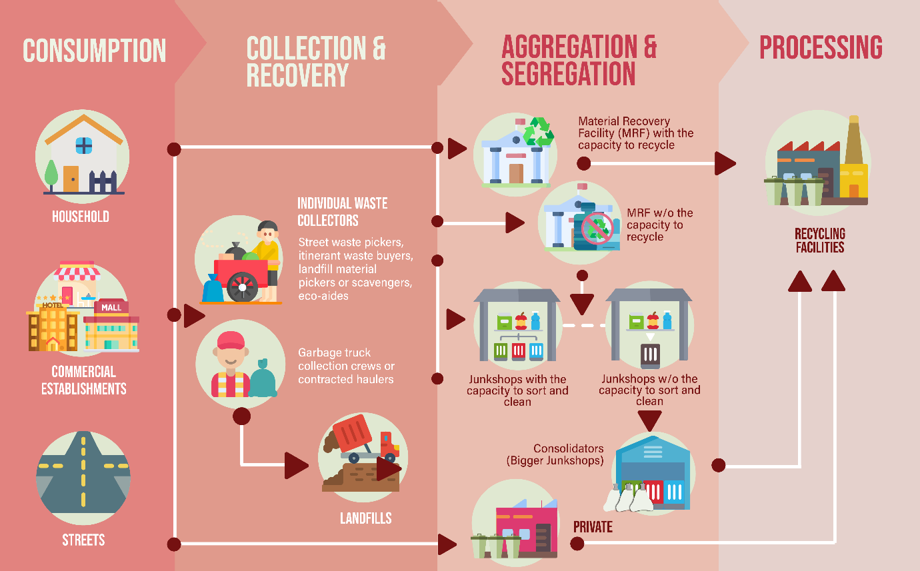

Based on Verite’s value chain analysis, PET products are collected right after consumption of the contents and as soon as PET is discarded, prompting the beginning of the recycling process. The collection stage includes the recovery and collection of PETs from municipal (post-consumer) and industrial (post-industrial) waste streams; this research focuses on the former. In the aggregation/segregation stage, PETs are sorted according to set criteria and those that do not meet these criteria (i.e., cannot be recycled) do not progress any further. In most cases, PETs are initially cleaned as well; or to be more precise, stripped of any undesirable components through the peeling off of labels or cutting out of sections with prints. PETs are then moved to the processing stage during which these are transported to facilities that have the technology to thoroughly clean the PETs and process them into flakes. Thereafter, PETs are transported to the next-level processors overseas, where more advanced technologies may be further applied to produce components, such as fibers, for the manufacture of a variety of products made out of recycled materials. A processor in Cavite province, however, has recently started operations and its management stated that it will cater to local or domestic needs, but primarily for the latter. At the time of interview, management reported that it had just concluded a transaction with a local business and was about to engage Coke’s bottling facilities in the Philippines for the flakes it produces.
While seemingly straightforward, PET recycling is actually a very complex supply chain involving individuals and entities of varying levels of formality in terms of employment, registration, or business operation. Most low-income actors are engaged only in the sorting and collection process, after which control passes to the aggregators which are mostly junk shops. Actors at the bottom-most tiers work under completely informal to partially-formal conditions, and labor and employment arrangements become more formal further in the top tiers.
The table below provides a detailed step-by-step process of PET recycling in Metro Manila and adjacent provinces covered in the study, and the workers involved in each stage and activity.
Table 6. Recycling activities by type of worker
Recycling phase | Major activities | Types of workers involved
Recovery and collection | Sorting out reusable and recyclable materials in residential or commercial waste containers, or in dumpsites  Selling and transporting these to junk shops and other recycling facilities  Cleaning PETs so these can be sold at a higher price | Waste pickers  Scavengers  Landfill material pickers  Garbage truck drivers and collectors
Aggregation and segregation | Consolidating and segregating the materials in different sections within the junk shop  Cleaning of uncleaned PETs  Storage of the materials until a specific volume and price are reached  Delivery to or pick up by companies who recycle the materials | Junk shop workers  MRF workers
Processing | Cold-washing or hot-washing of PETs to remove dirt and other contaminants  Turning the bottles into PET flakes and preparing them for export or for domestic sale | Workers in processing factories

Recovery and collection
Local government units (LGUs) in Metro Manila have systems in place to collect waste, including recyclable waste, involving private or public haulers as well as material recycling facilities. However, individual waste collectors continue to be prominent actors in the collection stage. Although they may be called many names, they have one fundamental role in the chain: to recover and collect recyclable materials such as PETs (as well as metals, glass, papers and boxes, aluminum, and other plastics) which are then offered for sale. Individual waste collectors generally rely on the transformation of recyclable waste as their main source of income. Their activities also help ensure that dumpsite waste is reduced to only organic waste.

Figure 4. Waste collection
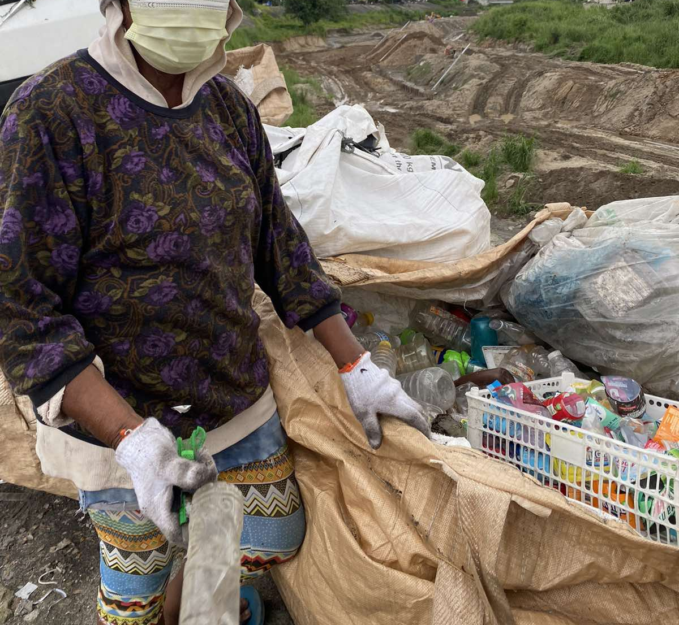

Individual waste collectors can be categorized based on source of recyclable waste. For this research, the following individual waste collectors were engaged:
Street waste pickers
Street waste pickers collect PET and other recyclable materials from waste left on the streets, either stored in garbage bins of residences and commercial establishments or left on the streets where no such bins are available.
Itinerant waste buyers
Equipped with pushcarts or karitons, they buy recyclable materials door-to-door. Their ability to buy materials such as bottles and paper waste products from consumers separates them from street pickers and so-called waste scavengers. They sometimes take loans from junk shop owners which they use to buy recyclable waste from homeowners.
Scavengers or landfill/dumpsite material pickers
Scavengers and landfill material pickers collect PET and other recyclable waste from disposal sites. This practice was well-documented in the Rizal Provincial Sanitary Landfill. According to KIIs, scavengers are allowed to go inside the landfill at specific times only and on a rotational basis. Scavengers can choose to take the morning or afternoon trips to the landfill. Landfill management reportedly implements this schedule to have some level of control over the number of scavengers inside the landfill at a given period and to avoid overcrowding. Researchers noted that some scavengers hitch rides on garbage trucks which are en route to the landfill, allowing them to save money on transportation.
Eco-aides
Eco-aides are organized door-to-door collectors of PET and recyclable materials under the management of local government units, mostly at the barangay level.
Eco-aides may perform other tasks, such as street sweeping. There are also eco-aides who, like itinerant waste buyers, take small loans from junk shop owners, or who use their own personal capital, to purchase recyclable wastes. Whichever the case, all types of eco-aides are monitored mostly at the barangay level.
In the city of Las Piñas, eco-aides in one barangay are called Recyclables Transporters. They are registered and provided uniforms and identification cards, ensuring that homeowners can easily identify them when they perform their tasks. They are also the only ones allowed to sell recyclable waste to the only junk shop in the barangay. The junk shop and barangay entered into an agreement stipulating that the former will only buy recyclable waste from uniformed eco-aides registered by the latter.
In the province of Cavite, eco-aides are also street-sweepers contracted by their respective barangays. After two hours of cleaning the streets in a day, they collect recyclable waste from the area. These eco-aides employ a different process in collecting recyclables from the neighborhood. Picking up recyclables from the streets while they are working is their default collection method, but some of them also buy small volumes of recyclables from households or stores.
Individual waste collectors are part of the informal sector, and make up the majority of the workers in the collection phase.
On the other hand, garbage haulers or collection truck crews are part of the more formal sector. Typically composed of drivers and haulers, they are employed by local government units (LGUs) either at the barangay or city/municipal level, or by private hauling companies contracted by the LGUs. They travel in garbage trucks of varying sizes, picking up and removing wastes and recyclable goods from residential neighborhoods, commercial establishments, and other public spaces (e.g., government offices, hospitals, markets, or parks). Their most common practice is house-to-house collection and collection of waste disposed in plastic bags or bins on the streets. Roles are straightforward: drivers navigate the streets; haulers, often called paleros or pahinantes, collect garbage at each stop. The waste collected is either disposed of in landfills or brought to waste facilities where they may be further sorted manually. The selling of recyclable waste by garbage haulers to junk shops to augment their income is a common practice documented by this research. These collectors play a significant and important role in supplying PETs to some junk shops.

Aggregation and segregation
After gathering recyclable waste, collectors transport these to aggregation or recovery facilities where the waste is sorted and PETs are collated, cleaned, and prepared for shipping to the next-tier facilities for further processing and manufacturing. The process of bringing recyclable waste to these facilities is akin to that of delivering raw materials to processing/manufacturing facilities.
Junk shops are the primary actors at this stage, and they are the go-to buyers of waste collectors. They can be considered the backbone of the PET recycling industry, and of the recycling industry in the country, in general.
Recyclable and scrap materials bought by junk shops are largely categorized under plastics, paper, batteries, glass, metal, and brass or tanso. Junk shop management interviewed stated that brass is the most profitable waste material. PETs, on the other hand, are not received or bought by all junk shops because processing them at this stage is relatively labor-intensive and takes up more space. PETs require the additional step of cleaning and the workstation needed for this operation as well as temporary storage for packed PETs for transport take up space. Smaller junk shops, in particular, have limited space for storage.
Junk shops surveyed for this research employ varying business models. Despite differences in activities, services, or strategies, junk shops generally follow the process below with regard to the processing of PETs from collectors. Buy-and-sell activities also appear to be common to all junk shops, regardless of business model.

Figure 5. Process flow for PET processing at junk shops

Junk shops may also have other sources of PETs and may have different customers for the PETs they process. As indicated in Figure 5, junk shops may buy PETs from individual waste collectors or may directly source these from households and commercial establishments as well. Larger junk shops are further able to obtain PETs from other smaller junk shops. These larger junk shops are called consolidators and they subsequently sell their PETs to processors.
Sorting through garbage bins is no longer an activity exclusively conducted by junk shops; in fact, only a few appeared to be still engaged in this activity. In this research, only five (5) junk shops were found to be engaged in sorting through garbage bins, and these were all operating in Payatas, Quezon City. Their business model includes receiving bags containing garbage which they buy directly from garbage collection trucks on a per-bag basis. According to the junk shop workers, these garbage bags come not only from Quezon City but also from other LGUs through their respective haulers.
Not all junk shops are also able to clean or transport PETs. Cleaning is dependent on whether the junk shop has enough personnel as it is considered to be one of the most laborious tasks in the junk shop. It involves the handling of each piece of PET bottle and cutting out labels or printed sections, pouring out residual liquids, and removing and segregating bottle caps. These tasks are usually performed by piece-rate workers, or workers who are paid per kilo of PET cleaned. Verité’s recent work in the sector has found that very few junk shops assign this task to their regular complement of workers, or workers who are paid a daily wage rate.
Transportation or delivery of PETs is most incumbent on whether or not a junk shop has a delivery vehicle. There were only a few junk shops in this research that own trucks and are able to handle their own deliveries. There were also those who rent trucks only for this purpose; the reported average rental rate is about PHP 3,000 / USD 55 per delivery trip. Those that have neither trucks nor the means to rent such trucks sell their collected PETs to consolidators who are responsible for picking up PETs from the junk shops.
Consolidators are usually larger junk shops that both have the trucks to transport PETs from smaller junk shops as well as the means or financial capital to purchase hundreds of kilos of PETs in one business transaction. In addition, they are also able to receive recyclable waste from large scale waste consumers and generators such as factories and other commercial facilities or establishments.
Another actor at this stage, albeit considerably quite small in number, are the LGU-led Materials Recovery Facilities (MRFs). These are special actors in the recycling industry in general as they are sometimes able to replicate the job of junk shops as aggregators, and also that of processors by engaging directly in the recycling activity and converting used PETs into other products. The text box below describes the varying ways LGUs manage their respective MRFs and solid waste systems.

IN FOCUS:
Waste management and MRF Practices in Select LGUs in Metro Manila

Quezon City
The Department of Sanitation of Quezon City (DSQC) is the LGU’s lead unit responsible for the city’s sanitation, waste management, and compliance with environmental laws, rules, and regulations. The DSQC is tasked with the development and direct administration of a Comprehensive Environmental Protection Program which specifically covers sanitation and waste management.

The LGU contracts a hauling company to collect waste within the city. The hauling company deploys four different kinds of trucks and the personnel complement (drivers and paleros) are compensated based on the size of the truck and computed on a per trip basis.

Quezon City has hundreds of junk shops in the city. However, not all are registered or have licenses to operate. Some junk shops reportedly delay getting a permit because of the costs associated with securing all the requirements. Some reportedly cannot afford to renew permits every year.

The city utilizes barangay units to monitor the collection of waste in the city. According to a DSQC staff member, there are MRFs and Material Recovery Systems in some of these barangays. In lieu of a centralized MRF, the city implements the BasuHero project, a trading activity in which recyclable materials generated from business establishments, barangays, and homeowner’s associations are traded for cash.

Parañaque City
The city’s MRF serves as a centralized research and management facility for its solid waste management division. It is operated by City Environment and Natural Resources Office (CENRO). The facility was operating on a 500-square meter lot at the time of research, and construction was ongoing to expand the area to about 900 square meters. The MRF has recycling equipment such as a bioreactor or a composting machine for kitchen wastes to generate fertilizers; a plastic chair machine used to make chairs using soft and clear plastics; and an eco-brick maker using sachets and other similar plastics as material input.

All employees in the city’s MRF are contracted and paid by the LGU through the CENRO. According to one employee, there are more of less a thousand MRF workers, indicating that this is a significant income and livelihood source to many citizens in the city.

Aside from the centralized MRF, eight (8) of the city’s 15 barangays have their own MRFs. The rest have contracted junk shops to serve as their MRFs.

Parañaque has its own hauling trucks which are dedicated to the collection of recyclable wastes such as PETs, soft and clear plastic wrappers, and other lightweight recyclables which could be repurposed to make other products. The city also has a partner junk shop for the other recyclable materials.

In addition to these, the LGU also implements the following recycling projects:
- Zero plastic sa landfill project – Plastics collected by LGU trucks are directly delivered to the MRF.
- Order ni Misis – Households are trained on waste segregation and classification to improve recyclable recovery and collection.
- Livelihood programs – There is a program which involves making bags from dried water lilies and used tarpaulins, and selling these to upcycling stores in La Huerta Public Market and Ayala Mall, both located in the city. These programs are implemented in coordination with the city’s Community Relation and Information Division.

The LGU also contracts a hauling company as well to collect the waste within the city. The contracted haulers collect residual wastes within the entire city which are then dumped in the sanitary landfill assigned to them by the Metropolitan Manila Development Authority (MMDA).

Las Piñas City
The city’s MRF is outfitted with recycling equipment such as a bioreactor and a recycled plastic chair manufacturing machine. The LGU also has its own garbage hauling trucks which collect wastes every day. These trucks then dump their collected waste at a transfer station located just behind the city MRF. A contracted hauling company delivers and dumps waste in the sanitary landfill assigned to city by the Mtro Manila Development Authority (MMDA). Drivers and paleros of the city garbage hauling services were hired under an emergency contract of the LGU through the CENRO.

Aside from recycling plastics into plastic chairs and kitchen waste into bio-fertilizer, other recycling activities are conducted through the LGU’s partnership with a private foundation. These further provide many people with livelihood opportunities.

Other Cities in Metro Manila
MMDA monitors every city in Metro Manila with regard to solid waste management. The MMDA is also responsible for monitoring the landfills where residual wastes are dumped.

Processing
Once collected and sorted by color, cleaned PET bottles are baled into large, compacted bundles and sent to the recycling facilities. In these facilities, PETs are ground into particles known as flakes. Flake purity is central to preserving the value of reclaimed plastic. Further separation techniques involve washing with the use of disinfectants and detergents, and air classification as well as water baths, allowing materials to either sink or float, thus separating residual foreign materials from the flakes. Washing can be undertaken through cold wash or hot wash.
After grinding, washing, and separation, PET materials are rinsed to further eliminate any remaining contaminants or cleaning agents. The recycled PET is then dried before reintroduction as a manufacturing material or before further processing. To further purify the material, facilities employ melt filtering to remove any non-melting contaminants which may have survived the previous procedures. Extruded materials pass through a series of screens to form pellets while non-melted particulates are blocked. Pelletized plastic provides a uniform-sized material that can be reintroduced later into the manufacturing process.
In the Philippines, some of the known recycling facilities that can carry out the entire procedure described above are Yu Li Jia Plastics (YLJ Plastics) and Toplun Plastic Industries, both operating in Valenzuela City.
Despite repeated requests for interview, notably with Toplun, the Valenzuela processors declined to participate in this study. However, researchers successfully secured an interview with and site visit to one processing facility based in General Trias, Cavite. PETValue, the first bottle-to-bottle recycling facility in the Philippines, resulted from a partnership between Coca-Cola Beverages Philippines, Inc. (CCBPI) the bottling arm of The Coca-Cola Company in the country, and Thailand-based Indorama Ventures, a recognized global leader in packaging solutions and green technology. PETValue officially opened for production in 2022.
The business model of PETValue is simple: recycle used PET bottles and turn them into food-grade level pellets that can be used to make PET bottles again or other packaging materials. PETValue relies heavily on used PETs, which are primarily sourced from partner junkshops in different parts of the country. With the help of CCBPI through its World Without Waste project, partnerships with local government units also enabled the facility to source bottles from clean-up projects and other initiatives undertaken by CCBPI and LGUs.
At the facility, the process of recycling starts with dumping the collected PETs on a conveyor machine, which allows segregation depending on color. PETValue is capable of both cold- and hot-washing, unlike some of its competitors. PETs thereafter undergo flaking or crushing, and pelletizing. PET pellets are transported out to clients, which in PETValue’s case, are local businesses. At the time of interview, management personnel stated that they just sold their first batch of PET pellets to a local business, and was about to engage CCBPI for its next transaction. Management divulged that CCBPI was supposed to be its first client to be serviced but circumstances dictated otherwise.
As CCBPI is a client of PETValue, a fact that surfaced only in the latter stages of research, it appears that the PET value chain in the Philippines has recently changed. Before PETValue commenced operations, the value chain ended with processors producing and shipping PET flakes/pellets for export. Since PETValue operations started, notably with domestic businesses as main clients, the value chain in the Philippines has been extended to the manufacturing of products. Per PETValue management, its clients produce food packaging materials (its first client) and PET bottles (CCBPI).

Working Conditions in the PET Recycling Industry
Working conditions in the PET recycling industry can vary immensely depending on the work process and the segment of the value chain. In this section, we categorize workers according to the level of formality and employment arrangement, and describe the working conditions that characterize the different types of work processes they are involved in.
As discussed in previous sections, workers’ employment arrangement can be broadly categorized into informal to partially or semi- formal, and formal. Formal employment, in this context, is understood as the type of employment that is legally regulated in terms of working hours and wages, and carry with it employment or labor rights as spelled out in the Labor Code; and informal employment is that which has none of these enforceable guarantees. While working conditions among semi-formally employed workers have some similarities with those in the formal sector, this research shows that there are more similarities in working conditions between them and workers in the informal sector. This section focuses on those working conditions common across the experiences of semi-formal and informal categories of workers, because majority of the workers in the sector fall under these categories.
The formal actors in PET recycling engaged in this research consist only of MRF personnel, LGU-employed garbage haulers or collection crews, and recycling facility employees. The informal actors consist of typically unregistered, unregulated individuals or groups, or those working in small businesses who are mostly concentrated in the collection and aggregation tiers. Drivers and haulers employed by private companies work under semi-formal employment arrangements.
People working in the informal recycling sector have higher exposure to poor working conditions and are health and safety hazards. Interviews and physical observations indicate that among these workers, there are almost no supervision and safety instructions, no guarantees of payment, benefits, or protections available to those in the formal sector. They earn low average earnings, that do not meet the minimum wage. The workers also typically live in some of the city’s poorest and most unsafe areas under degrading conditions. They have a low status in society, and often come from families that have lived under multi-generational poverty.
Some of the working conditions and features that characterize the employment and work arrangement of informal workers are also present in the conditions faced by truck drivers and garbage haulers who participated in this research. While some of these workers may have formal contracts with their employers, who may come from the public or private sector, these workers nevertheless lack the social protections accorded to formally employed workers such as regulated working hours, overtime premiums, rest days, paid leaves, and other benefits. They typically do not have job security – even the ones employed by local governments, who are contracted under so-called Job Orders, and are not considered as part of the regular plantilla or government personnel. Most truck drivers and haulers hired by private contractors also typically do not have formal contracts with the truck fleet owners, and in some cases their employment is made under informal arrangements.
The only workers who are formally employed with the full benefits and entitlements of regular employment are those in government MRFs who hold plantilla/regular positions and in facilities in the processing tier. In PETValue, management reported that it had 172 employees at the time of interview, with 80 of them working in the production floor as machine operators, forklift operators, production technicians, quality checkers, and warehouse personnel. Of these 80, half were under a six-month probationary status, two (2) were under fixed term contracts, and the rest have obtained regular employment as of the interview date. Management reported that they do not employ workers / employees under casual or seasonal employment arrangements and that the two fixed term contract personnel have been recommended for regularization.

Table 7. Recycling worker positions categorized by level of formality
Recycling phase | Formality level of working arrangement
 | Informal | Semi-formal | Formal
Recovery and collection | Street pickers  Landfill material pickers  Waste buyers | Waste pickers  Scavengers  Landfill material pickers  Garbage truck drivers and haulers | Some garbage truck drivers and haulers employed by local governments
Aggregation and segregation | Junk shop workers | Junk shop workers  Some MRF workers under job order contracts | Some workers in government MRFs
Processing |  |  | Workers in processing factories

Employment arrangements
The process and conditions under which workers are recruited and contracted for the job, or engaged in a productions process, can indeed vary significantly and spell the difference between formal and informal employment, and the consequent working conditions and protections available to the category workers fall under.
Collection workers
At the lowest tier of the PET recycling chain in Metro Manila are collection workers. Most collection workers are self-employed; they work for no specific employer or business and are not bound under any form of agreement with any enterprise. Their usual first point of contact is the junk shop or the recycling facility to which they sell their collected PETs. While they would typically gravitate towards selling to their preferred PET buyers, there are no verbal or written agreements restricting or prohibiting them from transacting with other junk shops, recycling facilities, or any buyers for that matter.
Eco-aides
Eco-aides, such as those in some barangays in Cavite province, are employed by the barangay to maintain the cleanliness of the neighborhoods by sweeping main roads or streets, usually for a set period of time. In the course of their work, they are also able to sort through garbage bins or pick up PETs and other recyclable waste as well. Eco-aides interviewed reported that, with regard to recyclable waste collected, they have the discretion to decide to which junk shops they will sell. Although employed by the barangay, their engagement is not full-time and they are not considered regular employees. They receive a compensation of about PHP 2,500 (approx. 48 USD) per month, which they say is barely enough for them and their families’ essential living expenses.
Garbage truck drivers and paleros
Unlike the highly informal set-up of individual waste collectors, garbage truck drivers and paleros undergo a more defined recruitment process. They are required to submit, at the very least, a biodata sheet or application form to the employer, typically a private company contracted by LGUs for purposes of garbage collection, solid waste segregation, and transportation to and disposal at designated sanitary landfills. There are also, albeit very few, garbage truck drivers and paleros who are directly employed by LGUs themselves.
In both cases, and regardless of the employer, all drivers and paleros interviewed reported a common working arrangement: they are only paid basic wages and do not receive any benefits. They are reportedly not provided paid leaves or legally mandated social welfare benefits. They also stated that their contracts are renewed every six (6) months.
The research found that there are several major actors in the aggregation tier who are also working under less than formal work arrangements. While collection tier workers have very common employment arrangements, aggregation tier workers work under terms and conditions which depend on the nature of their work.
Junk shop workers
Junk shop workers interviewed were hired under very rudimentary recruitment processes. Junk shop owners also reported that most of their workers were recommended by former workers or by family members. There are no set qualifications for the job and workers do not go through any screening process. They can be hired and fired at will; they are also free to leave their job whenever they want.
The majority of junk shops in this research employ around three (3) to five (5) full-time laborers. These full-time workers typically perform tasks ranging from junk shop manager or cashier, to general helpers / bodegeros (warehouse workers) / pahinantes or drivers. Junk shops also sometimes employ “extras”, or part-time on-call workers to help with the workload. These “extras” are typically engaged whenever there is a very large volume of recyclables to sort, clean, or process which can overwhelm the junk shop’s regular personnel complement. Junk shops’ regular worker complement and extras are paid wags on either a daily, weekly, or monthly basis.
Piece-rate workers
For work on PETs, junk shops generally engage piece-rate workers who mainly clean bottles and who are paid per kilo of cleaned PETs. Junk shops visited for this project had only a few PET workers who regularly work in the facility but, when necessary, they also hire extras who are likewise paid per kilo of cleaned PETs.
Figure 6. The personnel complement of junk shops
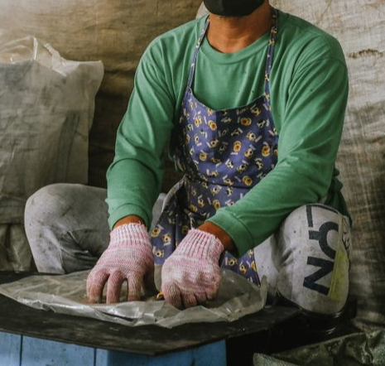Junk shop manager | 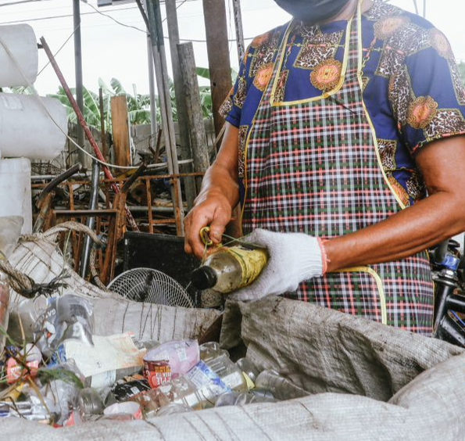Bodegero/ Pahinante/Helper | Drivers and Haulers/Paleros | 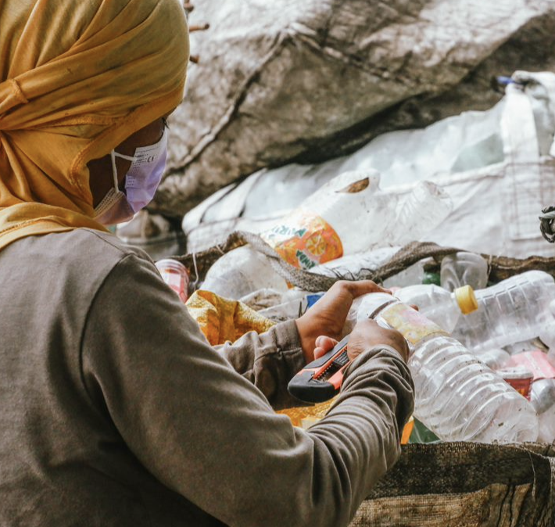PET cleaner
The manager oversees the day-to-day operations of the junk shop. They are often in charge of financial transactions and managing the cash register. | General warehouse workers and helpers receive, sort, clean, or process materials; and maintain the regular daily operations of junk shops. | They operate trucks for garbage collection and recycled materials delivery. | They are engaged in sorting bottles according to color, stripping or cutting out labels and prints; removing bottle caps and rings.

The number of PET cleaners who work in a junk shop is dependent on the volume of PETs to be cleaned: larger junk shops which can collect very large volumes of PETs are able to employ more PET cleaners. These junk shops also have more space in their premises, capable of not only storing bulky PETs but also providing necessary work areas for PET cleaners. Key tasks of PET cleaners include sorting bottles according to color, and removing labels by using cutting tools or by manual tearing. PET cleaners also remove bottle caps and rings, which can be sold separately. In some junk shops, cleaning may also involve washing PET bottles with soap and water, adding more value and increasing the bottles’ selling price.
Submission of any documentary requirements and previous work experience in junk shops are not prerequisites for hiring. Some junk shop owners reported that they hire persons whom they can trust, which they said is assured if such persons are referred by friends, family, or former workers. However, applicants for the position of driver must present a driver’s license which is appropriate for the job. But apart from this, no other requirements are imposed.
There are also no employment contracts signed between junk shop workers and owners; this very informal arrangement, according to owners, allows workers to leave anytime they want. According to junk shop owners interviewed, they cannot do anything if their workers decide to quit. All junk shop owners stated that their workers are free to leave any time they want, but some also said that workers' loans have to be settled in full before they leave the job. It is not uncommon, however, for some workers who still have loans (utang) to simply abscond or not show up to work, they said.
Since signing an employment contract is not a practice in junk shops, all agreements in terms of wages and working assignments are made orally between owner and worker. From the side of the workers, this means there is no formal instrument that they can use to claim agreed-upon wages and benefits, and other protections that formal contracts bring. Interviews and review of documents indicate that majority of the junk shop workers earn less than the legally mandated minimum wage to which they are entitled, unless the junk shop operates under an exemption provided under the BMBE law. None of the junk shops engaged in this research were registered as BMBEs.
Workers in MRFs, garbage truck collection
The MRFs work within government recruitment systems and workers are hired either as regular, contract, or “Job Order” (JO) workers. All MRF workers have to go through usual government recruitment processes which entail submission of identification and school records, registration to the social security service system, and signing of written employment contracts or agreements.
Based on our interviews, the garbage truck collection crews and MRF workers are the only ones who signed an employment contract, although many of them also only signed short-term contracts, and many went through multiple contract renewals. Drivers and paleros who are employed by contractors of city governments reported that their contracts are renewed every six (6) months. They also stated that they are free to leave their jobs anytime throughout the duration of their contracts, but they are likewise not assured of another contract or an extension once current contract expires.
It is notable that the precarious employment and contracting practices observed among privately employed truck drivers and crew are also present among those hired by local city government units. Both categories of collection crews do not enjoy paid leaves and other benefits; and are what is called a “no work-no pay” arrangement. While they may get permission to take a day off or file for sick leave, they will not be paid for those days in which they do not work.
Workers in processing facilities
Employment arrangements of workers in processing facilities are more defined; terms and conditions are stipulated in employment contracts between the workers and the company. At PETValue, management reported that employment contracts are signed in duplicate between workers and management after the contents are explained to the former, who may also ask questions. The employment contract template reviewed indicated that it contains typical stipulations about the work arrangement such as job position, wage, and the like. However, the contract lacks a stipulation about the probationary period, details about work hours (only a general statement about “regular working schedule”), clarity about the voluntariness of overtime (“require you to work outside such working hours… upon reasonable notice”), and clarity about termination rules (payment in lieu of one-month notice stating only as “paying salary”); elements such as these are commonly found in international best practice samples of employment contracts. The contract is also in English and management stated that there is no version in the workers’ language. In any case, workers in processing facilities, or at least in PETValue, are covered by a formal written employment contract unlike most other workers in the PET value chain.

Work hours
Work in the collection segment tend to be self-paced with no set working hours, while work in junk shops and aggregation tier tended to be more structured. However, even in the junk shops and the aggregation tier surveyed, there was an absence of any formal or systematic mechanism to monitor working hours. In general, management systems were very basic, often not standardized or formally in place in these establishments, such that workers often work beyond normal (eight) hours and sometimes render extended working hours, without breaks or any additional compensation. The working hours of junk shop drivers are especially unpredictable and difficult to track. Most drivers hired by contractors to LGUs have to complete their tasks in a day regardless of the number of hours it takes; while drivers directly employed by LGUs are able to have more regular hours.
Collection workers
Collection workers do not follow any strict or common working hours; they start and end work at their own convenience. All waste pickers interviewed reported that they work between five (5) to 10 hours daily, which is spent either conducting collection activities only or collecting and cleaning recyclable waste. Street pickers who sort through waste from restaurants, condominiums, and other commercial establishments typically start their day before dawn, sometimes as early as 4:00AM. They stated that they prefer to begin early in order to rummage through garbage bins before the waste is picked up by haulers during their rounds.
Collection workers who buy from recyclable waste from houses usually start their work at a much later time. They explained that they cannot start too early because they need to knock on people’s houses as part of their day-to-day work. In contrast, landfill material pickers from Rizal stated that their working hours are set to align with the time slots or time blocks prescribed by the landfill or dumpsite management.
Junk shop workers
Junk shop workers follow the operating schedules of their respective junk shops. The majority of junk shops in this research reported work hours starting at 7:00AM and ending at 5:00PM or 6:00PM; work weeks start on Mondays and end on Saturdays, with some also stating that there may be work on Sunday mornings. This typical schedule translates to workers rendering about 10 to 11 total hours per day, and about 60 to 66 total hours per week, inclusive of breaks. Most piece-rate workers such as PET cleaners, who have more control over their time, do not necessarily follow the start and end times of their junk shops. They can come and go whenever they want; but they also indicated that they work at the junk shop more than eight (8) hours in any given day.
Some junk shops allow their workers to stay or reside within the premises, which often results in workers continuing to work even when the shop has already closed. Stay-in workers reported that after the junk shop closes at around 6:00PM, they sometimes continue sorting through materials or cleaning PETs. In addition, they take care of junk shops’ overall housekeeping and keep the place secure against robbery and theft. The stay-in worker typically act as the overall “manager” of the junk shop, able to make daily business decisions in the absence of the owner. It is also common for owners to allow not only workers but also their families to reside within junk shop premises. At least two of the junk shops in this study have workers’ families residing within the premises. These families usually consist of wives, husbands, and their children. (See section on child labor and child presence).
A review of the operating hours of junk shops surveyed indicates a high likelihood that junk shop workers in Metro Manila normally work in excess of eight (8) hours per day. Of the 26 junk shops surveyed, more than half (67%) operate more than eight (8) hours a day for at least six (6) days a week.
Figure 7. Normal operating hours of junk shops surveyed

Junk shop drivers and helpers
Working hours of junk shop drivers are challenging to track compared to other types of workers. This is due to the unpredictable hours of delivery of their load to the recycler or processor, as well as due to varying road traffic conditions especially in Metro Manila. Their work schedules also do not always align with the operating hours of a junk shop. Helpers who accompany drivers unavoidably follow the drivers’ working hours.
Drivers interviewed reported that there are several factors which impact their working hours. The actual travel time from the junk shop to the next tier, usually a processor, will vary depending on traffic conditions on the day of delivery or transport. Some drivers also stated that they are sometimes stopped by local traffic enforcers or police for overloading or if their load is uncovered. More importantly, their working hours will depend on how fast or slow the recycling facilities can process their PET delivery. Processors sort through each load of baruga (very large sacks that contain the PET bottles) using a conveyor to check whether the bottles being sold pass their quality requirements. This process also includes sorting bottles according to color (white, green, blue), and cleaning the bottles or removing their labels. According to the drivers, they consider themselves quite lucky if the transaction with processors take only an hour, as the process usually takes longer.
Drivers and helpers employed by government contractors have more defined working hours as they are required to follow the schedule set by the concerned LGU.
Workers in processing facilities
Workers in processing facilities follow a stricter work schedule. PETValue management reported that the workers work in two (2) shifts, rendering eight (8) normal work hours per day and six (6) work days per week. Although there is no legal limits to overtime, and the facility’s procedures do not explicitly provide for the same, management stated that they observe a limit of three (3) overtime hours per day. Management added that all work is voluntary, but their procedures do not explicitly state the voluntary nature of overtime work.

Wages, income, and benefits
The majority of PET recycling workers’ earnings depend on the availability of recyclable waste. In general, the workers, even those who are formally employed, do not receive earnings that meet legal minimum wage levels.
Collection workers
Waste pickers and scavengers, and most collectors, do not receive wages. As noted in previous sections, they generate income by selling recyclable waste.
Figure 8. Average buying price per kilo of PET bottles
 | Preparation | Metro Manila | Cavite
 | Uncleaned | PHP 5 – 9 per kilo | PHP 11 per kilo
 | Cleaned | PHP 10 – 12 per kilo | PHP 17 per kilo

The prices of PETs range from PHP 5 to 17 (USD 0.08 to 0.29) per kilogram. Junk shops buy PETs at a higher price if the bottles are already cleaned, de-labeled, and sorted according to color. At current market rates, individual waste collectors reported their daily earnings from PETs, which they usually sell uncleaned, range between PHP 100 to 150 (USD 1.69 to 2.54).
Junk shop workers
Wage practices applied to different types of workers in junk shops vary greatly, from the amounts received to the frequency of wage payment. Regular junk shop workers or helpers are paid fixed monthly wages which are computed based on the number of days worked. Stay-in workers receive their wages every week or every two weeks. Most junk shops provide daily fixed wage rates. Wage practices become unclear when a family manages the junk shop, as seen in some junk shops whose daily operations are overseen by a family, typically consisting of a couple and their children who also live with them at the premises. In at least one junk shop, the husband’s tasks range from being a general helper to a pahinante who joins the deliveries, and the wife takes on the role of the cashier. They are not paid individually; rather, the husband-and-wife team collectively receives a wage of PHP 10,000 (USD 169.17) per month. (See section on Gender Equality).
Piece-rate workers interviewed reported that they can earn approximately PHP 250 (USD 4.23) per week, but that this depends on factors such as prevailing price per kilo of PETs or recyclable waste.
Workers in junkshops in Quezon City, Makati City, and Marikina City were found to receive the highest wages, but still, many don’t meet the minimum wage. Of the 26 junk shops visited, only five (5) provided wages that were on par with or higher than the applicable legal minimum wages, which are PHP 570 (USD 9.64) in the National Capital Region and PHP 435 (USD 7.36) in the Cavite province. Workers in the sampled junk shops in the City of Manila receive the lowest daily wage. All the junk shop drivers interviewed reported that they receive wages which are at least equivalent to the legal minimum wage, however, they often work beyond normal hours and do not receive an overtime premium.
Junk shop workers are typically not provided social welfare benefits such as SSS, 13th month pay, medical insurance, and others generally provided to employees in the formal sector. A few junk shop workers in the sample were enrolled in social security and welfare programs (SSS), but most of them made voluntary contributions with no employer counterpart. Only one (1) junk shop was found to contribute the employer’s share to their employees’ social welfare benefits. At least one (1) other junk shop owner stated that they used to give employer contributions but had to stop because of the financial challenges brought by the Covid-19 pandemic.
Junk shop owners may provide other benefits to their workers. For example, one junk shop in Cavite consistently gives workers (and partner waste collectors) gifts such as rice, groceries, and cash every year during the Christmas season. Other junk shops provide free meals, and stay-in workers reside within the premises of junk shops rent-free. These practices, however, do not appear to be common.
Figure 9. Average daily wages of junk shop workers
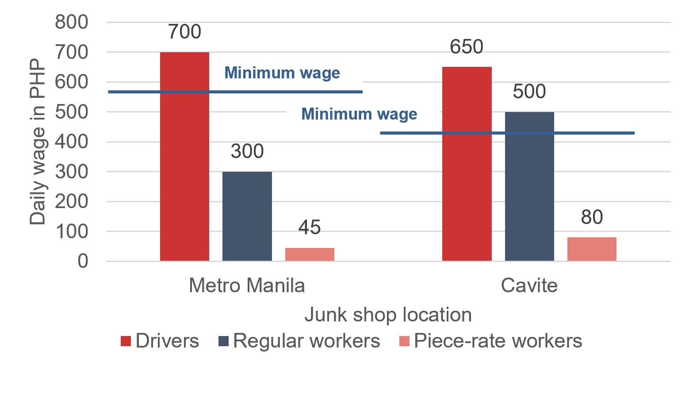

Table 8. Overview of Working Hours and Wages by Worker Category
 | Work Hours |  |  | Wages
Daily rate / regular workers
City | Work schedule | Hours worked per day | Days worked per week | Wages  PHP per day unless otherwise noted | Frequency of Wages
Manila | 6am – 5pm | 10 hours | 7 days | PHP 250 | weekly
Makati | 7am – 6pm | 9 – 10 hours | 6 days | PHP 500 – 600 | weekly
Marikina | 7am – 6pm | 9 – 10 hours | 7 days | PHP 600 | weekly
Valenzuela | 6am – 6pm | 8 – 12 hours | 7 days | PHP 400 – 500 | weekly
Quezon City | 8am – 5pm | 8 hours | 6 days | PHP 300 – 700 | weekly
Quezon City – Payatas | 6am – 7pm | 9 – 10 hours | 6 days | PHP 300 – 500 | weekly
Rizal | 8am – 5pm | 8 hours | 6 days | PHP 450 | weekly
Cavite | 7am – 6pm | 8 – 10 hours | 6 days | PHP 350 – 650 | weekly
Drivers
Cavite | 7am – 5pm (dawn if deliveries are scheduled) | 9 hours | 6 days | PHP 650 | daily/bi-monthly/
Piece-rate workers
Quezon City – Payatas | 7am – 5pm | 9 hours | 6 days | PHP 3 per kilo | daily/bi-monthly/
Cavite | 8am – 5pm | 8 hours | 6 days | PHP 4-8 per kilo | daily/bi-monthly/

Garbage truck drivers and haulers
Although they are formally employed under different types of contractual arrangements, garbage collection truck drivers and helpers face similar challenges related to social welfare benefits.
Quezon City’s garbage collection contractor employs a compensation scheme for their drivers and helpers which takes into account the size of the truck to which they are assigned. As seen in the table below, the workers are paid on a per trip basis; hence, the more trips they do in one day, the higher the pay they will receive. The crew interviewed reported that they perform their rounds within Quezon City every day, except Sundays.
Table 9. Wage rates for drivers and paleros in Quezon City
Truck size | Wage/Payment  per trip | Number of trips  per day | Number of staff type per truck
For Garbage Truck Drivers
Smallest unit | PHP 275 | 3 – 5 | 1
Medium | PHP 275 | 2 – 3 | 1
Large | PHP 500 | 1 – 2 | 1
Extra Large | PHP 800 | 1 trip per day | 1
For Paleros
Smallest unit | PHP 150 per person | 3 – 5 | 2 – 3
Medium | PHP 150 per person | 2 – 3 | 2 – 3
Large | PHP 250 per person | 1 – 2 | 4 – 5
Extra Large | PHP 400 per person | 1 trip per day | 4 – 5

The information above indicates that all drivers can earn wages which are above the legal minimum wage, even those assigned to small trucks. If drivers complete at least three (3) trips in a day, then they earn at least a daily total of PHP 825 (USD 13.96). However, paleros, or helpers, assigned to small to medium trucks with the same number of trips per day are at risk of receiving wages which are below the applicable legal minimum wage.
In Las Piñas City, collection truck crews interviewed reported that they are paid a fixed daily rate. Drivers reported receiving a daily wage of PHP 487 (USD 8.24) and helpers reported a daily rate of PHP 350 (USD 5.92), which are both below the PHP 570 (USD 9.64) legal minimum wage set for workers in non-agricultural jobs in Metro Manila.
Table 10. Comparison of earnings of drivers and helpers in Quezon City and Las Piñas
Area of Operation | Wage calculation method | Reported trips  per day | Wage  per trip | Minimum expected daily wages
For Garbage Truck Drivers
Quezon City | Per trip | 3 – 5 | PHP 275 for smallest unit | PHP 825
Las Piñas | Flat rate | N/A | N/A | PHP 487
For Paleros
Quezon City | Per trip | 3 – 5 | PHP 150 per person for smallest unit | PHP 450
Las Piñas | Flat rate | N/A | N/A | PHP 350

In terms of benefits, Quezon City contractors’ drivers and paleros interviewed reported that while their employer provided assistance in filing their social welfare contributions, there are no employer counterpart contributions. The entire amounts they pay to social welfare—i.e., SSS, Philhealth, and PAG-IBIG—are automatically deducted from their wages. In Las Piñas City, LGU contracted drivers and paleros are deducted amounts for their PhilHealth and PAG-IBIG (housing) contributions.
To augment their wages, collection truck crews sometimes sort through the trash that they collect from residential or commercial establishments and directly sell whatever recyclable waste they are able to “harvest” to junk shops. The crews reported that they receive an additional 10% on top of the selling price from the junk shops, which encourages loyalty to the junk shop. This practice was documented specifically in Payatas, Quezon City.
Workers in processing facilities
In PETValue, management reported that the facility pays its workers legal minimum wage rate, and that they follow the applicable legal overtime rates, and provides workers with the trifecta of legally mandated social benefits (SSS, PhilHealth, and PAG-IBIG). Zero-interest loans are available for regular employees who have rendered at least one (1) year of service, but management stated that no operators have yet to avail of the same as of the interview date. Employees also receive 13th-month pay annually (pro-rated where applicable) regardless of the length of service.
While the processing facility visited by the researchers appear to show good practices with regard to the provision of minimum wage and other benefits, researchers note that anecdotal or initial information indicated that there are workers in similar processing facilities who do not appear to earn at least the legal minimum wage. Wages should therefore remain as a critical area of concern even for formally employed workers.

IN FOCUS:
Wages of Drivers and Paleros in Las Piñas

The garbage collection truck workers of the city of Las Piñas are usually contracted under an “emergency contract” that is renewed every six (6) months.

One LGU truck is usually staffed by one (1) driver and two (2) helpers or paleros. Doing the rounds from Monday to Saturday, the crew starts its rounds within their areas of responsibility at 4am and ends at around noon. However, it is a common practice for collection crews to work more than eight (8) hours a day, especially when their assigned truck is on maintenance and they have to wait for other trucks to become available.

After their first round, they will return the truck to their base of operations, and then wait again for a good amount of time for another truck to become available in order to do a second round of collection. When this happens, they exceed their usual eight-hour tour of duty to be able to complete the required two collection trips per day. They have no choice but to wait for the second truck to be available; otherwise, they will not be paid even if the reason for the delayed availability is beyond their control.

Drivers receive a daily wage of PHP 487 per day and helpers are paid PHP 350 per day, regardless of truck size, number of trips, schedule/overtime, and length of service. Their wages are released every 15th and 30th of the month but they reported frequent cases of delayed payments. Because of the nature of their contracts, employers do not contribute to their workers’ social welfare benefits (i.e., SSS, PhilHealth, Pag-Ibig). LGUs reportedly require that their workers pay voluntary contributions to these benefits, and workers stated that their remittances are automatically deducted from their salaries.

Table 11. Comparison of employment characteristics of actors in PET value chain
Topic | Collectors  (street pickers, landfill site pickers, waste buyers) | Junk shop workers | Material recovery facility (MRF) workers | Garbage truck drivers and haulers | Workers in processing factories
Are there requirements for recruitment? | No | No | No | Yes  Biodata, NBI clearance, Brgy. clearance, Police clearance, Medical certificate | Yes  Resume, Certifications (eg, forklift), Vax records, Filled out application form, Questionnaire for behavioral test  TIN – ID or tax forms – copies, Copy of SSS, Pag-ibig, Philhealth, Diploma and TOR – copies, Training certificates, Cedula, NBI and police clearance – original, Barangay clearance (needed by bank when opening account), BIR 2306, Birth certificate, self and children, Marriage certificate, Referral letters, Previous pay slip, Medical exam results, COE
Are formal contracts or agreements in place? | No | No  No formal contracts typically, although they have an employer-employee relationship with junk shop owners | Yes  They are contracted by their respective city government unit under the City Environment and Natural Resources Office (CENRO) | Yes  Contracts may be private, as in Quezon City, or with the local government unit (LGU), as in Las Piñas. | Yes  Contracts are explained well to hired employees, and they are also given physical copies.
Daily wage or income reported by workers  Average or typical range, unless otherwise noted | PHP 500 – 1,000  in Metro Manila depending on type / volume of recyclables sold to junk shops, including PHP 100 – 150 from PETs | PHP 250 – 600 depending on the city where the junk shop is located |  | PHP 350 - 487  set rate for drivers and paleros in Las Piñas, respectively.  PHP 500  per day in Quezon
Do workers receive mandatory benefits?  (13th month, sick leave, etc...) | No | No | No | Benefits vary by contract.  In Las Piñas, these workers do not receive paid sick leave, but in Quezon City they do. Workers may not receive SSS or overtime pay.  Workers receive a mid-year and/or end-year bonus. | Yes  With employer contribution to SSS, PAG-IBIG, and PhilHealth. They are also entitled to paid leaves like vacation, sick, and maternity leaves. They also receive 13th-month pay and paid  overtime.
Average daily work hours | 10 – 12 hours | 8 – 10  hours |  | 8 – 10  hours | 8 hours Overtime rarely happens.

Job security / livelihood
As noted in previous sections, only a small percentage of workers in the sector (those in the processing segment, and a few in the MRFs and trucking/transportation) have regular employment, formal contracts, and job security with opportunities for advancement and building new skills, and improving their socio-economic conditions.
Across the various job types, Verité noted widespread precariousness and systemic barriers that prevent most workers from securing a job, maintaining a stable income and a decent living, and improving their access to resources and their status in society.
Street waste pickers
In profiling the workers, the study shows that street-waste pickers, workers in the lowest tiers of the supply chain have very low levels of literacy and formal education, poor language proficiency, and limited access to basic amenities and social protection. All of these factors compound their ability to negotiate better pay and conditions, access other livelihood opportunities, and improve their socio-economic conditions and social mobility. During interviews, it was noted by researchers that many waste pickers come from families and parents whose parents before them were involved in waste-picking and other informal income-generating activities. (See also Child Labor and Child Presence). None of the waste-pickers were aware of any programs they can access to grant them alternative skills and livelihood opportunities.
Piece-rate PET cleaners
In various locations visited for this research, PET cleaners working in junk shops have no formal contracts with junk shops though they tend to have regular or steady stream of work, as long as there are available PETs for them to clean. No other training or skills are provided to them, and none of them had worked in formal settings previously. They are paid on a piece-rate basis and no other guaranteed incentives or benefits.
In Payatas, Quezon City, PET cleaners are paid at the rate of PHP 3 (USD 0.05) per kilo of sorted and cleaned PET bottles. At an average of eight (8) hours of work in a day, cleaners reported that they can produce no more than 10 kilos per day, which results in a daily earning of about PHP 30 (USD 0.51). This amount, according to the PET cleaners, is not sufficient to even cover a decent meal for themselves or their families. As such, they would sometimes prefer to have their cleaned and sorted PET bottles weighed weekly in order to earn a higher income of at least PHP 250 (USD 4.23).
PET cleaners in junk shops in other areas, especially those with higher volumes of PETs, reported a different experience. They reported that some of them can clean more than 50 kilos a day, resulting in daily earnings of about PHP 150 (USD 2.54) at the same rate of PHP 3 (USD 0.05) per kilo. Benchmarked against currently applicable legal minimum wages, it is clear that PET cleaners earnings are insufficient, even if they clean and sell as much as 100 kilos of PET per day.
Garbage truck drivers and haulers
Garbage truck crews also face other factors which affect their capacity to earn and keep their jobs. Some Quezon City contractors’ drivers and paleros indicated that their income and job security are at risk if they are caught selling their collected recyclable waste to junk shops which are not partnered with their company. They would be required to surrender the vehicle’s key, depriving them of the opportunity to earn income for the day because they are compensated per trip. In Las Piñas, garbage truck drivers and paleros also reported many instances wherein their wages would be delayed for five (5) to 10 days; they recalled that the worst delay lasted about three (3) weeks. These delays occurred despite the formal employee-employer arrangement in place between them and the LGU. They stated that the resulting income and financial issues would force them to borrow money from other sources to be able to support daily needs.
Workers in processing facilities
In PETValue, management reported that half of the 80 workers in the production floor were under probationary status as of the interview date; two (2) were under fixed term employment arrangement but were already recommended for regularization; and the rest have been regularized. Management added that the facility does not employ seasonal or casual workers.
Verité notes, however, that contractualization or employing workers on short term contracts (e.g., duration of less than six months) to circumvent regularization has been a widespread practice in many businesses in the Philippines.

​Freedom of association
None of the workers engaged in this research are members of any associations or groups organized for the purpose of protecting their interests and welfare. Moreover, the study indicates that most actors in the collection and aggregation tiers—from workers to business owners—are not aware about the concept of freedom of association and right to organize as it relates to the workforce.
However, the study indicates that many of the junk shops and their owners are members of junk shop associations in their respective cities. These associations (some are cooperatives) are composed of junk shop operators and members are primarily engaged in exchanging or sharing information about prices, and supply and demand of recyclable materials. These associations are also venues for the discussion of issues relevant to their operations within their localities, and for coordination or consultation with their respective LGUs local government unit as a group. Interviews indicated, however, that working conditions do not appear to figure prominently in these associations’ efforts.
Linis Ganda, an association of junk shop operators, actively partners with local and international companies on several environment-focused programs and initiatives. As of this writing, the association has an ongoing partnership with a multinational consumer goods company in the Philippines in which junk shops buy plastic wrappers of shampoos from waste collectors and then directly sell these to the said partner. This program is a targeted approach aimed at minimizing dumped plastic wrappers in landfills.

IN FOCUS:
Associations in other countries
focusing on non-environmental advocacy in the recycling sector

There are good examples of associations operating in the recycling sector in other countries which focus on other areas beyond environmental advocacies.

The Movement of Excluded Workers (MTE), the biggest waste pickers’ cooperative in Buenos Aires, Argentina with more than 2,500 members, established a nursery for 160 children who used to work as waste pickers as part of their fight against child labor with funding from both MTE itself and the local and national governments. In June 2017, MTE also opened an educational centre “Anuillan” (meaning determined woman in Mapuche language) where the members who dropped out of school for various reasons could complete their studies. Around 30 students between 18 and 55 years of age come to the school three times a week.

In South Africa, the Mooi River Recycling Cooperative provides their members and non-member waste pickers with training on waste sorting and hazardous waste handling. The members also receive additional benefits such as extensive education on waste recycling, skills training on processing of various types of waste, training on business administration, computer literacy and management, as well as protective clothing and recycling equipment.

Safety and health in the workplace
Workers engaged in the PET value chain in Metro Manila and nearby provinces, notably in the collection and aggregation tiers, work in conditions with high risks of exposure to occupational safety and health (OSH) hazards.
Individual collectors, notably waste pickers, are at very high risk of exposure to OSH hazards because they operate on their own with no training no instruction, no visible or accessible means to access protective equipment and other means of OSH support.
Researchers noted that the work of collectors involves exerting great physical effort over extended periods of time while being exposed to the elements (i.e., extreme heat and rain). Researchers also observed that the majority of waste pickers do not have adequate personal protective equipment (PPEs) to protect themselves against apparent hazards when gathering or handling recyclable waste. Moreover, they do not have reasonable access to safe, clean, and public sanitary facilities in the course of their daily work.
In junk shops, the level of compliance with applicable OSH standards is also visibly low. Registered junk shops must comply with certain requirements in order to obtain the necessary permits such as a Sanitation Permit and Fire Safety Permit. However, beyond this compliance area, researchers noted that junk shops have not established systems or practices to ensure overall OSH compliance as provided under existing regulations. There is also an apparent lack of awareness about OSH requirements that apply to business ventures such as junk shops.
During field visits, researchers noted that most junk shop workers do not wear or are not provided appropriate PPE such as gloves, masks, others. Workers interviewed reported that they prefer not to use or wear any PPE, saying that these are “not convenient to wear since it is hot.” Some junk shop workers also refuse to wear face masks while working because according to them these make breathing more difficult, especially when lifting heavy materials. In effect, the workers work for extended periods of time exposed to potentially hazardous particulates and substances produced by waste materials which they process and handle on a daily basis. Of all the junk shops surveyed, only one (1) in Metro Manila provides facemasks and ethyl alcohol to their employees, which is a practice prompted by the ongoing pandemic.
First aid kits were found in only a few junk shops. One (1) junk shop in Cavite has a first aid kit which appears to have the most comprehensive contents such as medicines, cotton, ethyl alcohol, and band aids which is available not only for their workers but also for waste collectors.
In terms of fire safety, there are junk shops which only have one clear point of egress in case of an emergency, which is also the result of the shop’s limited space. Emergency routes are also observed to be obstructed by or cluttered with materials which pose slipping or tripping hazards. The pathways are typically uneven and not well-lighted.
Practices concerning materials storage, ergonomics, good housekeeping, and maintenance of premises likewise do not meet current national OSH standards. While there is some general organization of materials in junk shops, cutting, tripping, and falling hazards are visible among the junk shops visited for this research. There were no visible efforts to ensure that the impact to workers’ bodies resulting from heavy lifting, repetitive movements, and the like were being mitigated.
Around the junk shop premises, it was also common to observe uneven ground, wet or slippery surfaces, and pathways cluttered with materials. There were no visible signs to demarcate walkways for pedestrians or areas to be kept clear, or signs to indicate danger or warnings.
At the processing facility, all employees, whether working on the production floor/area or not, receive a complete set of protective equipment such as hard hats, gloves, safety shoes, and vests. Additional PPEs, earmuffs or earplugs, eye protection, and face shields, are provided to those directly involved in production. Workers must wear their PPEs when they move around the facility and within the compound. Upon hiring, all staff also receive a one-week training on health and safety. They are provided with basic knowledge and skills on first aid, and mandated to undergo fire and earthquake drills. According to the management, these are necessary as several certification bodies may conduct surprise visits to check on their compliance with various environmental, and health and safety standards.

Child labor and child presence
During site visits, researchers observed that some waste pickers were accompanied by their children or young persons (aged 17 and below) while collecting waste materials. Children or young waste pickers were likewise observed to be selling recyclable waste to junk shops while interviews for this research were being conducted. Some junk shop owners noted that it is difficult to restrain or prohibit children and young persons from transacting with them because collecting and selling recyclable waste is a viable means for these children to earn or augment their families’ incomes, especially when they live on the streets.
The practice of involving children is not uncommon among individual waste collectors or workers in junk shops. Many waste pickers themselves start in this work as children, collecting waste materials from streets and households. Most of the children engaged in waste collection have parents who are or were also waste pickers. Many of these families live in the streets, and children grow up engaged in waste collection and not able to attend or sustain attendance in schools.
In junk shops, stay-in workers bring with them their families, children included. At least one (1) worker claimed that, sometimes, involving their children in work cannot be avoided, and they allow their children to help out while they work in the junk shop. As previously noted, stay-in workers who are also couples are collectively paid by junk shops. However, the wages paid pertain to the work rendered by the couple and not those rendered by their children.
In cases where housing is provided to workers, the housing accommodations are located within the junk shop premises or compounds. There is no clear separation or adequate barriers between the accommodations and the junk shop work areas, largely because junk shops have insufficient space to begin with and businesses typically maximize whatever limited space they have. Such physical arrangements allow children to easily loiter into the work areas where they would play or help their parents.
The risk of child labor or presence in processing facilities is relatively low. In PETValue, management reported that they have systems in place to verify workers’ age which are strictly implemented. Workers are required to submit documents, such as copies of their birth certificates, upon which their age can be verified during the recruitment, selection, and hiring processes. However, while it does not have any cases of child labor and age verification procedures are in place, the facility does not yet have child labor remediation procedures, a feature required in many international best practice standards.

Gender equality​
There is an apparent gendered division of work in junk shops. Although most of the junk shop workers who participated in this study are women, researchers noted that most junk shop workers are male. Junk shop owners stated they prefer male workers for more strenuous work such as lifting heavy recyclable waste like metals and cartons; and they prefer female workers for work such as sorting and cleaning PET. Female personnel are also preferred for tasks done by cashiers and shop managers.
Notably, there is a very significant difference in wages paid to male and female workers in junk shops, with the former earning at least 200 percent more than the latter. As previously noted, PET cleaners, who are mostly women, are paid on a piece-rate basis or per kilo of PET processed; regular junk shop workers, who are mostly men, are paid a daily wage. Both types of workers rarely receive wages that meet the applicable legal minimum; however, the gap between wages or earnings is significant: approximately PHP 100 to 200 (USD 1.69 to 3.39) per day for PET cleaners who are mostly female, and about PHP 350 to 500 (USD 5.93 to 8.47) per day for other junk shop workers. (See also section on Wages/Income).
These findings complement existing literature about women in the recycling sector. The waste sector is a largely unregulated sector facing social stigma and economic deprivation. In addition to these occupational challenges, women in the waste sector face competing demands from domestic and childcare responsibilities. The physical nature of some of the tasks involved, as well as health and safety issues, add further layers of concern for women engaged in waste management.
Women and men have different behaviors when it comes to generating waste, and their roles and tasks in households and communities vary when it comes to waste management and related activities. They also have different capabilities and access to opportunities when seeking employment in small waste enterprises.
In light of these challenges and limitations, one junk shop in Cavite stands out because of its efforts to champion gender equality in the recycling sector. This junk shop is owned and managed by a woman and employs an all-woman team of five (5) workers. These women workers perform work that is typically performed by male workers in other junk shops, such as driving the delivery truck, and lifting or moving heavy materials.
Figure 10: Workers in a woman-owned junkshop with all women workers
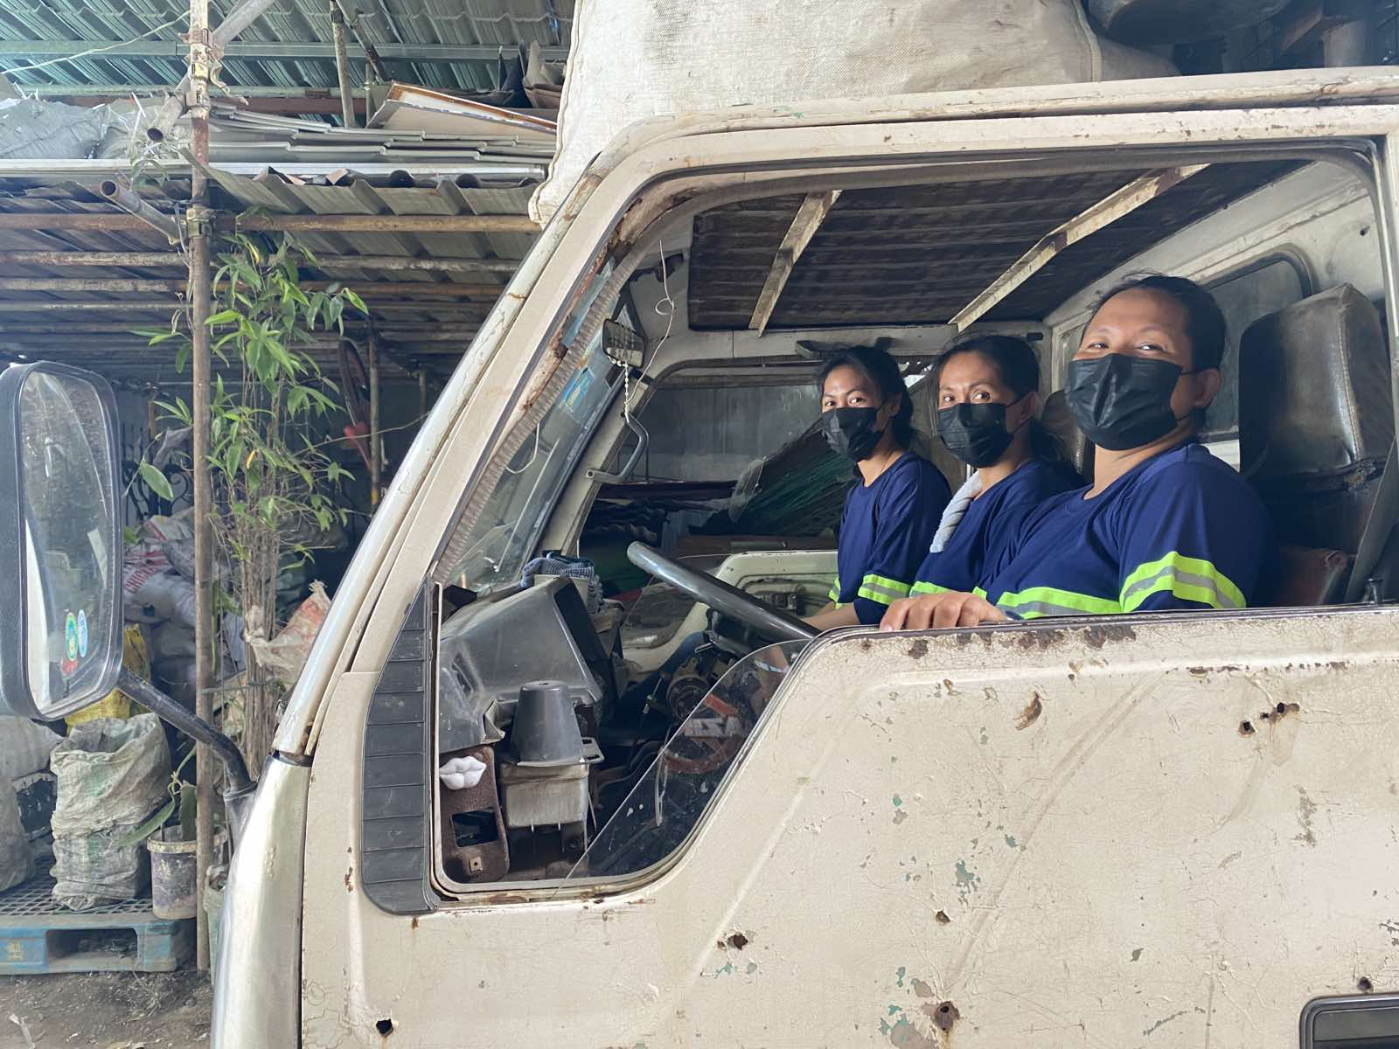
In PETValue, management reported and sample job advertisements presented for review confirmed that there are no sex and gender requirements during their recruitment, selection, and hiring processes; and that the typical main criterion is years of work experience. Of the 172 employees, management reported that approximately 80% are male and 20% are female as of the interview date. On the production floor, 76 male and 11 female employees comprise the 80 production workers and seven (7) supervisors.

Workplace security
Junk shops do not employ security guards and some junk shop owners interviewed reported that there have been incidents of theft in their establishments, committed by either unknown persons or their own workers. They also reported that there have been instances when they are sold recyclable materials which turned out to be stolen goods. In at least one junk shop, researchers’ visit and interviews were temporarily paused when local authorities arrived to inquire about certain stolen materials which may have been sold to junk shops in the area. Junk shop owners stated that if incidents like these occur, they typically return the materials free of charge.
Anecdotal information obtained from certain respondents indicated that some dumpsite locations are not properly secured and that criminal activities are reportedly rampant in these sites, which raise issues regarding the safety and security of waste pickers, some of whom are minors or children, who operate in these areas.
In PETValue, management reported that the facility has engaged one security agency / contractor, which deploys five (5) security guards to their premises. There were no reported security breaches so far since the facility commenced operations.

Property rights
Junk shop owners involved in the study either owned the land on which their businesses are located or leased the property, which appears typical for such establishments. Researchers noted that there also appears to be a correlation between the junk shop owners’ rights over their land and the capacity to provide better working conditions and arrangements to their workers.
Researchers observed that junk shops whose owners own both the buildings and the lands on which such buildings are erected exhibited more deliberate efforts at maintaining good housekeeping. They indicated that they introduce gradual improvements to premises as part of taking care of their investments, such as by installing firewalls. In contrast, junk shops owners who lease the land where their shops are located indicated that would typically think twice before they installing permanent structures such as firewalls.
Aside from physical improvements, researchers also noted there may be better provisions for workers in junk shops on land owned by the businesses’ owners. Only two (2) junk shops in the study reported paying employer contributions to their workers’ social welfare benefits (and this was stopped temporarily due to the pandemic). In both cases, the owners of the junk shops owned the land upon which they operate.
Junk shop owners who operate on leased land reported constant struggles to pay the monthly dues, which ranged from PHP 10,000 to 50,000 (USD 169.40 to 846.98). Lease or rental rates depend on location, among others. Some owners also struggled with short- or fixed-term lease arrangements; this was experienced by the owner of a junk shop in Cavite. The junk shop can only lease the area for about two (2) years at a monthly lease of PHP 20,000 (USD 338.79).
Small-scale junk shop owners prefer to operate at their homes, converting parts of their residential premises into work areas, because of expensive prices of land and the costs of building the needed infrastructure.
Similar small-scale junk shop owners who lease the land indicated that they prefer to hire and maintain only one or two workers to cut back on operational costs because lease or rental rates are expensive. High operational costs in these junk shops also result in owners paying their workers lower daily wages.

Factors affecting working conditions
Researchers noted several factors that appear to contribute to the either the improvement or deterioration of working conditions and welfare of workers in the PET value chain in Metro Manila and nearby provinces.

Supply and demand
The supply and demand of PET bottles can affect the working conditions of workers in the recycling sector in various ways, such as increasing workloads and productivity pressures during periods of high demand, or decreasing job security and wages during periods of low demand, which can lead to poor working conditions and job instability. Additionally, fluctuations in the supply and demand of PET bottles can also impact the overall viability and sustainability of recycling businesses, which can indirectly affect the job security and working conditions of workers in the sector.
Junk shop owners, notably those who have been in the business for a long time, noted that there has been a significant decrease in the price of PET bottles over the past five years. They stated that five or more years ago, they used to be able to sell PETs to recycling facilities at rates which are at least double the current prevailing market rates. For instance, white PET bottles were previously bought at PHP 20 to 25 (USD 0.34 to 0.42) if uncleaned, and at approximately PHP 40 to 45 (USD 0.68 to 0.76) if cleaned, while at present, uncleaned PETs were bought at PHP 5 to 10 (USD 0.08 to 0.17) if uncleaned, and at PHP 20 to 28 (USD 0.34 to 0.47) if cleaned. According to the junk shop owners, the market value of PETs fluctuated in part due to the pandemic.
Junk shop owners further reported not being able to rely solely on PET bottles as their main source of income, as there are other more expensive recyclable materials; e.g. paper products such as karton (cardboard) or metals like tanso (brass).

Solid waste management practices of LGUs
On the supply side of PET bottles, another contributing factor is the system of waste management in the localities where collectors and aggregators are operating. LGUs’ waste management systems have similarities but there are also variations, with some implementing initiatives which appear to improve the effectiveness of the city’s efforts.
LGUs in Metro Manila typically contract garbage haulers to collect, segregate, and dispose waste in designated sanitary landfills. The haulers’ paleros usually segregate the waste they collect and sell recyclable waste, including PETs, to junk shops en route to the landfills for additional income. Most cities have hauling trucks for garbage collection. These garbage truck collectors can collect large volumes of PETs during their rounds since most household waste includes PET containers.
MRF systems and practices in Metro Manila have the capacity to collect and recycle waste materials; however, as previously noted, MRFs appear to be either centralized (city-managed), decentralized (barangay-managed, assigned to select junk shops), or some combination of both. MRF operations also vary, depending on each unit’s technical capabilities, among others. In the cities of Parañaque and Las Piñas, for example, MRFs have their own equipment for composting and/or making plastic chairs. Only a few MRFs appear capable of reusing and recycling PET bottles.
Despite the projected growth of the industry, waste recovery practices can still be improved. Segregation efforts at the household and community level are still not sufficient, resulting in low levels of recovery of recyclable waste such as PET bottles. This means that a very large volume of PET bottles may still remain unrecovered and may eventually end up in landfills or polluting the sea. Existing waste management systems and practices may need to be improved to ensure that recyclable materials do not end up in landfills or oceans, consequently increasing the volume of PETs and other recyclable materials which can be sourced by collectors and aggregators in the PET value chain.
Waste management practices can significantly impact working conditions as inadequate waste segregation, sorting, and disposal can expose workers to health hazards and safety risks.

Level of formality of businesses
The level of formality of businesses in the PET recycling supply chain can influence workers’ job security, access to social benefits, and compliance with labor standards. Workers in informal businesses face greater job insecurity and poorer employment terms and conditions.
Junk shops engaged in this study are either registered or unregistered enterprises, which reinforces findings from Verité’s previous work in the sector. Junk shops with small-scale operations indicated that they may not have the financial resources to secure the necessary permits and licenses, or to meet certain physical or infrastructure requirements. The study also found that there are areas where junk shops are not allowed to operate.
For instance, in San Mateo in the province of Rizal, junk shops are prohibited from operating and are not provided licenses by the LGU. However, there are junk shops which continue to operate in the area despite the LGU’s warnings and instructions to stop their operations. Employment arrangements in these junk shops are similarly not formalized and the high risk of closure adversely affects workers’ job security, among other conditions.
Registered junk shops appear to have the capacity to provide better wages and benefits to their workers. Although the wage rates provided do not meet the legal minimum, these establishments are able to compensate their workers with higher daily rates. Some junk shops are also able to provide assistance to their workers with regard to their SSS benefits, albeit under the voluntary contribution scheme.
On the other hand, formal businesses may have more resources to invest in worker protection, training, and fair labor practices, as experienced by the interviewed workers in the processing facility.

Customer or buyer requirements
Customer and buyer requirements can have a positive impact on working conditions by enforcing strict social and labor standards throughout the supply chain and mandating that suppliers improve their labor practices. This is already being implemented by several multinational companies across different sectors, including high-risk industries such as agriculture and seafood where labor practices are deeply rooted. Additionally, Verité's engagements in the recycling sector in at least three jurisdictions indicate that global brands are starting to delve deeper into their supply chains; and suppliers such as collectors, aggregators, and processors have increasingly become points of interest with regard to responsible sourcing and social compliance standards.

While multinational companies in other high-risk sectors have already implemented such requirements, the fragmented nature of the PET value chain, which includes small and family-owned businesses with limited resources, may hinder compliance efforts and would therefore require an approach that involves more than one or a handful of actors in the supply chain.

PETs are also one of many recyclable materials available for actors in the waste value chain, and other recyclable materials can offer higher returns for collectors and aggregators. It remains to be seen how market forces can influence responsible sourcing and social compliance this deep into the supply chains.
At present, there are limited transparency and traceability mechanisms, and still-undefined accountability among various actors in the PET recycling supply chain. There are almost no traces of a cascading of information on social and labor standards, or any resources and support for lower-tier supply chain actors to understand and implement basic social (and legal) standards, from the part of their buyers, all the way to the processing facilities where their products end up in and which form part of a larger, global supply chain.
Nevertheless, there appear to be efforts underway to tackle social compliance issues at this level. PETValue, The Coca-Cola Company Philippines’ supplier of recycled pellets, has incorporated several elements of social responsibility standards in their screening of new suppliers. According to the management, they only deal with suppliers that have all the required permits, which also limits their options because this weeds out junkshops, no matter the capacity to supply PET bottles, that do not have business and other necessary permits. There is a Supplier Code of Conduct (SCoC) in place which PETValue shares with their suppliers, and encourages them to comply with. Management reported that there is a plan to conduct regular/annual audits of their suppliers to monitor their compliance with the SCoC.
The SCoC contains the specific elements pertaining to compliance with legal requirements, ethics, a few labor-specific standards on freedom of association and collective bargaining, diversity and equality, work hours and wages, child and forced labor, and some requirements on health, safety, and environment.
The SCoC, however, does not yet contain provisions on sanctions, or steps that should be taken in case suppliers do not comply with the social responsibility requirements. According to the management, they are not yet at the level of enforcement. There are still challenges in meeting their target volume because they are not getting enough PET bottles; therefore, terminating a relationship with a supplier or not transacting with one because of noncompliance is not option at this point.
Interestingly, PETValue’s suppliers are not limited to junkshop aggregators. They also buy cold-washed flakes from other recycling facilities like Toplun, YLJ, and Infinity—some of the biggest processors in the country. While they state that it would be easier for these processors to comply with the legal requirements (business permits, specifically), management also stated that there are challenges in conducting a full social responsibility audit because they are at the mercy of these big processors-suppliers, who are also technically their competitors. As of the interview date, PETValue has only shared their SCoC with these facilities, but no audit has been conducted nor planned as yet.
Another limitation noted is the limited scope of current auditing tools that PETValue utilizes. Currently, they only have a Supplier Audit Checklist which does not capture some of the elements in their already limited SCoC. The Checklist only looks into the following:
- Company documents (for accuracy and validity)
- Number of manpower complement and skill
- Child labor prohibition
- Health and safety awareness of employees
- Use of PPEs at work
- Awareness of segregation system (control and remove screen printed bottles, control, and remove screen printed bottles, control and remove pet trays)
It should be noted that the SCoC and the Checklist are documents cascaded to them by their Indorama partner’s office in Thailand. There is therefore a huge opportunity for PETValue to customize these documents in order to better reflect their commitment to the Philippine labor law and other international standards on labor and social responsibility.
There is also no supplier training program in place as yet, which could provide the necessary technical support to suppliers to better understand and comply with SCoC requirements.

COVID-19
The COVID-19 pandemic has impacted the recycling industry as a whole just as it has impacted other industries; however, the actors operating in less formal to highly informal arrangements in the recycling industry appear to be the most severely affected. Lockdowns brought about business closures and slowdowns which impacted waste pickers’ and junk shop workers’ incomes. Because informal waste pickers and other industry workers are not recognized as essential workers, and because these workers typically work under a no-work-no-pay arrangement, many of them were not able to earn an income during lockdown periods.
Moreover, many junk shops had to terminate the employment of some workers during the lockdowns, or had to cease certain benefits or practices. One junk shop had to let go of half of the six (6) workers it used to employ. Another junk shop which used to assist their workers with regard to their social benefits (SSS and PhilHealth) had to stop rendering assistance due to the pandemic. At the time of the research, the junk shop owner stated that they have yet to resume such assistance because they had only just started to recover from staggering losses brought about by the COVID-19 pandemic.
However, researchers also noted a good practice. There were a few junk shops that provided a daily allowance for their workers during the pandemic.

Other initiatives
With increasing demand for recycled PETs, there has been a notably significant movement in collaborations between the different actors in the value chain to ensure compliance with environmental and product-specific standards. Junk shops appear to be gaining a more prominent role in campaigns for environmental awareness, proper waste disposal, and recycling. Quite a number of multisectoral initiatives are aimed at junk shops and even individual waste collectors in order to improve the efficiency of waste collection and management, which also appear to result in increasing the supply of PETs for recycling purposes.
IN FOCUS:
A Multisectoral Initiative Led by Plastic Bank

Plastic Bank (PB) is a social enterprise which is globally recognized as a thought leader, advocate, and innovator in plastic recycling. Their main purpose is to reduce ocean-bound plastic which is chronic not only in the Philippines but also in other countries with inadequate or inefficient solid waste management.

A partnership between PB, The Coca-Cola Company Philippines, and Indorama Ventures, which involves selected junk shops in Metro Manila and Cavite province, aims to lessen ocean-bound plastic while reducing poverty through the Ecosystem Impact Program.

PB engages street sweepers as eco-aides in some areas in Metro Manila and Cavite. These eco-aides collect and sell PETs to PB’s partner junk shops, which buy the collected PETs at a price which is higher than those offered by junk shops not partnered with PB.

Annually, PB honors their partner eco-aides and junk shops by giving them equipment like weighing scales, carts, tumblers, caps, gift certificates, and cash incentives for their contribution in helping the environment become plastic-less.

Another notable project is The Coca-Cola Company’s "World Without Waste" project, a global initiative that aims to collect and recycle the equivalent of every bottle or can it sells worldwide by 2030. In the Philippines, the company has committed to the same target. The project primarily focuses on environmental sustainability and partnerships have been forged with local governments, NGOs, and other stakeholders to improve waste collection and recycling infrastructure, promote proper waste management practices, and raise public awareness about the importance of recycling.

While the project primarily emphasizes environmental sustainability, it also provides additional financial incentives that benefit collectors, aggregators, and their workers. More importantly, it also presents a unique opportunity to comprehensively address the social and labor issues that arise in the PET recycling sector, and offer more sustainable solutions to improve the working conditions of the most vulnerable workers.

Verité notes that programs such as The Coca-Cola Company’s "World Without Waste" project may be crucial entry or takeoff points to introduce programs that tackle systemic issues and challenges related to human rights, and labor and social compliance.

IN FOCUS:
Ensuring Program Sustainability through Incentives and Supply Base Consolidation

In recent engagements, Verité notes the following initiatives developed and undertaken by companies in addressing human rights issues in the PET recycling sector.

In Mexico, a company published a “child labor free supply chain policy” and established a program to support the policy involving all key supply chain actors and parallel interventions to address more systemic child labor root causes. The company conducted communication and outreach activities, and funded programs in high-risk areas such as the following:

- Providing free transportation for the children of pickers who work in landfills to attend childcare and learning centers and health and nutrition care;
- Providing free education, meals, and health care for children of an impoverished community, implemented in partnership with a Mexican NGO;
- Providing support and awareness raising programs to parents on domestic violence and abuse issues;
- Reaching out to the landfill company in a high-risk area, as well as to municipal authorities and pickers themselves, to re-purpose a storage building into a childcare, feeding, education, and support center.
In the Philippines, the following actions, among others, were undertaken by a global company:

- Consolidated the PET supply base – according to a set of criteria – in order to make the supply chain management program more efficient, providing selected junk shops direct support;
- Implemented a capacity building program on occupational safety and health (OSH), specifically designed for and provided to selected junk shops, taking into consideration the shop-owners’ challenges and inherent limitations in complying with applicable OSH requirements;
- Supporting junk shops to address the presence and hiring of minors in junk shops through training and provision of resource materials (e.g., no child labor signs);
- Piloted an incentive scheme conditioned on the payment by junk shops of the legal minimum wage (in spite of possible BMBE exemption), in which selected junk shops were provided premium payments for participation in the program;
- Provided key staff of processing facility with formal training on social compliance standards, towards enabling them to monitor and manage selected junk shops.

Conclusions and Key Points for Consideration
The social issues in the PET recycling sector identified by this study are complex, and many of their root causes are interlinked and systemic in nature. It is clear that certain issues like child labor, exposure to hazardous working and degrading living conditions, and the absence of any social protection are more pronounced among lower-tier worker-categories, such as waste collection and aggregation; while issues related to precarious employment, working hours, safety and health concerns, lack of safety training and personal protective equipment, inadequate compensation, and limited opportunities for upward mobility, are more cross-cutting.
Despite the existence of legal regulations and international standards and conventions guaranteeing principles and rights at work that the country is party to, issues remain widespread and unaddressed. This is owing to gaps in and weak enforcement of existing national legal frameworks; low awareness and ability of employers and other lower-tier supply chain actors to implement workplace improvements; and inability of workers to organize, seek support, and advocate for better conditions. These issues are particularly evident in the segments of the value chain where work arrangements operations are largely informal and unregulated, though even in sectors where there is more formality in terms of employment arrangements, industry (and government) practices such as the use of short-term contracts, ‘Job Orders’, and general lack of systems to ensure compliance with labor regulations, lead to workers facing precarity, poor working conditions, and below legal wages and benefits.
It is also apparent that other factors such as gender and sex, age, literacy, and social status exacerbate these workers’ vulnerability to these issues; and concerns related to reproductive health and gender rights, warrant more attention.
Another key concern highlighted in this report is the lack of transparency and traceability mechanisms, and still-undefined accountability among various actors in the PET recycling supply chain. This contributes to the slow (almost nonexistent) cascading of social and labor standards, and the delivery of much-needed resources and support to ensure their implementation, from the part of large brands down to the lower tiers of their supply chain. These gaps and their impacts are exacerbated in locations where labor regulations and worker protections are poorly enforced. Other factors and unanticipated events like the pandemic, have also had a detrimental impact on the working conditions in the recycling industry, and the ability of small business owners to comply even with basic legal requirements.
These findings emphasize the urgent need for increased attention on the situation of workers in the PET recycling industry; and definitive actions to address challenges and barriers to workers’ ability to exercise their right to decent working conditions, regardless of their status and the segment in the supply chain they belong to.
As the UNGP on Business and Human Rights indicates, “Business enterprises should respect human rights... avoid infringing on the human rights of others and should address adverse human rights impacts with which they are involved...”
Addressing these adverse impacts meaningfully may entail a long and circuitous journey, but it can begin with understanding what these adverse impacts are, who are most affected, and where these are most prevalent. This study fulfills this important step to a large extent, but understanding what business practices and transactions, management systems and operations drive these risks, and where changes may be made is also necessary. Mapping out all the production and relevant auxiliary processes related to the final product, and understanding where and how human rights and labor rights risks surface is critical. Once this is in place, increasing transparency, defining accountabilities, and committing to them to ensure sustainable and responsible practices across the supply chain is an important concrete response. This needs to be followed through with the establishment of practical programs on the ground that contribute to addressing actual adverse impacts and mitigating risks and potential impacts; and incorporating into the programs mechanisms to monitor and ensure that these are delivering the desired results. Additionally, these monitoring mechanisms should be inclusive and take into account the feedback and response of key stakeholders: junk shop owners and their employees, individual waste collectors, garbage haulers, truck drivers, among others.

Moving Forward: Key Points for Consideration
- Strategic, collaborative, and multi-stakeholder approach
Given the complexity and the systemic nature of some of the issues, and the wide gamut of actions that must be taken to address them, there is a need for increased collaboration and coordination among various actors. Solutions may be best approached as a multi-stakeholder effort that takes into account the specific needs and vulnerabilities of the workers, the limited capacity and capabilities of small and informally-organized businesses, the legal and regulatory environment; and the resources, accountability, and responsibility of downstream supply chain actors.
As serious as the issues that this report has highlighted are, they are not new or unique – many of these are present in industries with complex supply chains to which brands and buyers have limited visibility, and where work and production processes are labor intensive and employment arrangements are largely informal. The recycling industry players can learn from multi-stakeholder initiatives in the seafood/fishing, palm oil, and cocoa/chocolate, and cotton industries. Top players like The Coca-Cola Company can align with their peers on standards and commitments to ensure that PET recycling and informal workers are protected and recognized by regulatory frameworks, and that they do not remain at the fringes of the society and economy. They can jointly commit resources and global brands such as The Coca-Cola Company may lead the formation of a multi-stakeholder initiative - involving other private sector groups, relevant nongovernment / civil society organizations, and in coordination with pertinent government bodies – to address these issues and establish governance and monitoring structures to ensure sustainability efforts deliver the desired results.
Specifically, Verité puts forward the following points for consideration of a multi-stakeholder initiative:
- Develop a governance structure for the multi-stakeholder initiative and determine the roles and responsibilities of participating stakeholders;
- Develop a general set of standards on human rights and labor rights in the PET value chain in particular, and recycling sector in general, which is consistent with existing legal and regulatory framework and attuned to the circumstances of the various tiers in the sector;
- Develop and implement adequate, effective, and sustainable programs and projects in support of and to ensure compliance with the general set of standards across the PET value chain / recycling sector;
- Develop and implement adequate, effective, and sustainable communication and training programs for the PET value chain / recycling sector in general;
- Develop and implement adequate, effective, and sustainable human rights and labor rights monitoring systems, which include risk assessment and management, audits and assessments, and corrective and preventive action management, as well as monitoring for improvement.

- Strengthening supply chain compliance and monitoring mechanisms
For stakeholders in the PET value chain, Verité puts forward the following recommendations for consideration:

For brands and companies, including CCBPI, PETValue and other processors in the PET value chain
Regardless of whether a multistakeholder platform or organization is established, specific steps and actions are offered for consideration by buyers/customers sourcing recycled materials from the Philippines and countries (where the conditions are the same), and processors in the PET value chain. Since the research belatedly surfaced that CCBPI is a recent addition to the PET value chain in the Philippines and it is one of the early clients of the processor PETValue, Verité thus deems CCBPI to be in a strategic position to carry out initiatives independent of multi-stakeholder efforts described in No. 1 above.

Buyers, such as CCBPI, can also consider the following key action points for the improvement of its supply chain management program with regard to PET products. Sustainability, supplier engagement, procurement, legal and social compliance, and other related functional units are the key business units for these action points.

- Establish and communicate written policy commitments specifically to minimize and address adverse impacts on workers in the PET recycling sector, which adhere to international legislations and customer requirements;
- Embed these commitments not just in the programs of sustainability and human rights departments, but also in sourcing and procurement, supplier selection, and other business units;
- Prioritize specific issues – among the ones identified in the report – and develop clear targets, making them a basis for the development of practical and results-oriented programs that can be implemented in cooperation with other stakeholders;
- Develop and implement a compliance program in support of said commitments (for labor and human rights) for PET supply chain actors, or review and revise existing compliance programs to include said actors within their scope, with such programs consisting of the following components, among others:
  - Risk assessment and management;
  - Audits and assessments;
  - Corrective and preventive action management;
  - Monitoring for improvement and effectiveness;
- Clearly communicate these commitments and requirements to supply chain actors, and initiate capacity-building and support programs to ensure everyone in the supply chain understands and implements the requirements;
- Develop and implement strategies and schemes to ensure that PET supply chain actors remain in business relationships within the chain, while concurrently ensuring compliance with applicable standards on labor / human rights.
  - Pricing mechanisms may be reviewed, and incentive programs implemented (e.g., premiums on sustainable products are provided as an incentive for compliance);
  - Higher tier / formal processing facilities can be capacitated to implement supplier management and monitoring programs, to ensure all operations and production processes across the value chain are sustainable and meet legal and customer requirements;
  - Lower tier supplier facilities and work sites (e.g., junk shops) can be included in capacity building programs designed specifically to address most salient issues in their operations;

- Parallel initiatives to support internal supply chain mechanisms

- Engage governments at the national and local levels, with the aim of strengthening legal protections and creating an enabling environment for sustainable practices to flourish;
  - Policy and regulatory reforms to protect workers in the informal economy should be pursued. At a minimum, workers should be able to enjoy the most basic protections and social benefits such as guaranteed minimum wage and enrollment in government social protection programs (SSS and PhilHealth).
  - These protections have to be incorporated into existing conceptual and operational frameworks on the informal economy in the Philippines, and supported and strengthened by frameworks and parameters of internationally-agreed definitions put forward by the ILO, and various standards on business and human rights that guide governments and the private sector on the protection of workers, no matter where they are in the world and what they do or what industry they are involved in, from labor rights abuses.

IN FOCUS:
Advocating for inclusion of “informal” workers into legal protection schemes
A sample approach from the seafood industry

Verité has been actively advocating inclusion of international business and human rights standards in other sectors with high concentration of informal activities, for example, in the fishing sector. While significant challenges remain, there have been developments eased by the enactment of a specific Department Order that specifically recognizes the nuances of the fishing sector but also puts forward recommendations and policy guidance on what Filipino fishers are entitled to. The same can be done for the informal workers in the waste management and recycling industries. These workers have only started to become visible in the last few years, owing to growing concern about their welfare, but their contribution to the booming economy of recycling have also long been unrecognized. Clear policy guidance from the government will ease the efforts of the private sector to address issues in the informal sector; while the direct involvement of the private sector and the more formal actors in the recycling industry will help ensure that the informal workers in their supply chains are not exploited.

- Partner with government, leveraging or scaling up existing successful private-public initiatives
  - Segregation and collection processes at village/barangay and household levels can be improved, and programs like Linis Ganda can be leveraged;
  - Communities and villages where materials are sourced can be provided additional resources such as appropriate PPEs, segregation facilities, etc.;
  - Families and individuals engaged informal work processes, such as picking, collection, and cleaning can be linked to existing government- and NGO-run programs (e.g., health and safety trainings, food security programs, etc.);
  - Other programs – establishing childcare/child-minding facilities, feeding programs in schools, transportation programs for workers’ children – that are proven to reduce child labor incidence at community levels may be replicated

- Engage other stakeholders in the establishment of grievance, feedback, and communication mechanisms for small business owners, workers, worker-groups and civil society organizations; so they can provide input to the programs and participate in the process.
For the junk shops and junk shop associations, and representatives of individual / self-employed workers in the PET value chain.
As they are part of the extended PET value chain, junk shops, junk shop associations, and representatives of individual / self-employment workers can be engaged by CCBPI (and other brands and companies) to be part of sustainability programs and supply chain management efforts. They can do the following:

- Serve as key resources to obtain information and insights about the issues and challenges of actors operating at the deepest levels of the PET value chain, which will serve as basis for policymaking, program development, and other action plans to ensure human rights and labor rights are addressed;
- Serve as the vital link between the informal sector, mainly consisting of the most vulnerable actors; and government, businesses, and other entities in the formal sector in the development and implementation of interventions for the PET value chain / recycling sector;
- Cooperate with their buyers and PET processing facilities to pilot compliance programs at their level – focused on key areas such as legal registration of the business, provision of wages that meet legal standards, innovations in OSH and child protection –
and can serve as examples for other junk shops to model after.
- Involving Other key Actors
The responsibility to address these challenges, and work towards creating more just and equitable workplaces, and ensure the long-term sustainability of PET recycling in the Philippines, need not fall solely on the shoulders of the private sector. Other actions for consideration by government and civil society stakeholders are forwarded as well.
Government:
- Coordinate with other stakeholders in the PET value chain / recycling sector with regard to the multi-stakeholder initiative;
- Review solid waste management systems and practices, and incorporate human rights and labor rights therein;
  - For the purpose, establish coordination, or improve existing coordination between government units involved in the regulation and management of labor / human rights (including occupational safety and health) and solid waste management / waste recycling;
- Provide training to or improve existing training programs for actors in all the tiers of the PET value chain in particular, and recycling sector in general, on the following matters:
  - human rights and labor rights,
  - occupational safety and health,
  - basic business registration,
  - other related matters;
- Provide assistance and support to the most vulnerable actors in the PET value chain to ensure or improve access to existing government programs and projects (e.g., access to livelihood projects, child-minding facilities, cooperatives).
Non-governmental / civil society organizations in the recycling sector:
- Coordinate with other stakeholders in the PET value chain / recycling sector with regard to the multi-stakeholder initiative;
- Incorporate human rights and labor rights in projects and programs, or coordinate or partner with relevant government, business, or other entities in ensuring that human rights and labor rights are equally ensured protection along with existing environmental advocacies;
- Provide assistance and support to the most vulnerable actors in the PET value chain to ensure or improve access to existing government or nongovernment programs and projects (e.g., access to livelihood projects, child-minding facilities, cooperatives).

References
United Nations Office of the High Commissioner on Human Rights. (2011). Guiding Principles on Business and Human Rights. New York and Geneva. Retrieved from https://www.ohchr.org/sites/default/files/documents/publications/guidingprinciplesbusinesshr_en.pdf
Markets and Markets. (2023, March 13). Recycled PET Market. Retrieved from www.marketsandmarkets.com/Market-Reports/recycled-pte-market-248965407.html
Business Mirror. (2018, July 3). PET bottles have 90 percent retrieval rate in the Philippines. Retrieved from https://businessmirror.com.ph/2018/07/03/pet-bottles-have-90-percent-retrieval-rate-in-the-philippines/
International Labour Organization (ILO). (2013). Decent Work in Waste Management: A Baseline Study on the Ward Contractor System in the City of Windhoek. Retrieved from www.ilo.org/wcmsp5/groups/public/@ed_emp/@emp_ent/documents/publication/wcms_242573.pdf
International Labour Organization (ILO). (2022). ILO Declaration on Fundamental Principles and Rights at Work and its Follow-up. Retrieved from https://www.ilo.org/wcmsp5/groups/public/---ed_norm/---declaration/documents/normativeinstrument/wcms_716594.pdf
International Labour Organization (ILO). (n.d.). 23. Working Conditions. Retrieved from www.ilo.org/global/topics/dw4sd/themes/working-conditions/lang--en/index.htm
Ateinza, Vella. (2010). Sound Strategies to Improve the Condition of the Informal Sector in Waste Management. Retrieved from www.eria.org/uploads/media/Research-Project-Report/RPR_FY2009_10_Chapter_5.pdf
International Labour Organization (ILO). (2013). Women and Men in the Informal Economy: A Statistical Picture. International Labour Office, Geneva. Retrieved from www.ilo.org/wcmsp5/groups/public/---dgreports/---stat/documents/publication/wcms_234413.pdf
Presidential Decree No. 442 (1974), as amended and renumbered, in relation to Section 9, Chapter I, Rule VII, Book III, Omnibus Rules Implementing the Labor Code. (n.d.). Retrieved from https://www.ilo.org/global/WCMS_155246/lang--en/index.htm
Antonio, Lisa. (2009). Chapter 3: Study on Recyclables Collection Trends and Best Practices in the Philippines. Retrieved from www.eria.org/uploads/media/Research-Project-Report/RPR_FY2009_10_Chapter_3.pdf
Leblanc, Rick. (2020, April 8). Recycling Polyethylene Terephthalate. Liveabout.com. Retrieved from www.liveabout.com/recycling-polyethylene-terephthalate-pet-2877869
Sara, H. H., Bayazid, A. R., & Quayyum, Z. (2022). Occupational Health Sufferings of Child Waste Workers in South Asia: A Scoping Review. International Journal of Environmental Research and Public Health, 19(14), 8628. https://doi.org/10.3390/ijerph19148628
The Ocean Conservancy. (2019, June). The Role of Gender in Waste Management. Retrieved from https://oceanconservancy.org/wp-content/uploads/2019/06/The-Role-of-Gender-in-Waste-Management.pdf
MB.com.ph. (2022, October 13). Creating a Better Shared Future: Coca-Cola World Without Waste Programs and Partnerships Since 2018.

Markets and Markets. “Recycled PET Market.” Updated March 13, 2023. Available at : www.marketsandmarkets.com/Market-Reports/recycled-pte-market-248965407.html
Markets and Markets. “Recycled PET Market.” Updated March 13, 2023. Available at : www.marketsandmarkets.com/Market-Reports/recycled-pte-market-248965407.html
Business Mirror. “PET bottles have 90 percent retrieval rate in the Philippines.” July 3, 2018. https://businessmirror.com.ph/2018/07/03/pet-bottles-have-90-percent-retrieval-rate-in-the-philippines/ A
Business Mirror. “PET bottles have 90 percent retrieval rate in the Philippines.” July 3, 2018. https://businessmirror.com.ph/2018/07/03/pet-bottles-have-90-percent-retrieval-rate-in-the-philippines/ A
International Labour Organization (ILO). “Decent Work in Waste Management: A Baseline Study on the Ward Contractor System in the City of Windhoek.” 2013. www.ilo.org/wcmsp5/groups/public/@ed_emp/@emp_ent/documents/publication/wcms_242573.pdf
Metro Manila is composed of the cities of Manila, Quezon, Caloocan, Las Piñas, Makati, Malabon, Mandaluyong, Marikina, Muntinlupa, Navotas, Parañaque, Pasay, Pasig, San Juan, Taguig, and Valenzuela; and the municipality of Pateros.
ILO Declaration on Fundamental Principles and Rights at Work and its Follow-up, 2022. https://www.ilo.org/wcmsp5/groups/public/---ed_norm/---declaration/documents/normativeinstrument/wcms_716594.pdf
International Labour Organization (ILO). “23. Working Conditions.” www.ilo.org/global/topics/dw4sd/themes/working-conditions/lang--en/index.htm
Ateinza, Vella. “Sound Strategies to Improve the Condition of the Informal Sector in Waste Management.” 2010. www.eria.org/uploads/media/Research-Project-Report/RPR_FY2009_10_Chapter_5.pdf
International Labour Organization (ILO). “Women and Men in the Informal Economy: A Statistical Picture.” International Labour Office, Geneva. 2013. www.ilo.org/wcmsp5/groups/public/---dgreports/---stat/documents/publication/wcms_234413.pdf
Article 294, Presidential Decree No. 442 (1974), as amended and renumbered.
Article 295, Presidential Decree No. 442 (1974), as amended and renumbered.
Article 295, Presidential Decree No. 442 (1974), as amended and renumbered.
Article 296, Presidential Decree No. 442 (1974), as amended and renumbered.
Article 99, Presidential Decree No. 442 (1974), as amended and renumbered.
Article 98, Presidential Decree No. 442 (1974), as amended and renumbered.
Effective 04 June 2022.
The daily minimum wage rates are based on a regular eight-hour workday.
Article 101, Presidential Decree No. 442 (1974), as amended and renumbered, in relation to Section 9, Chapter I, Rule VII, Book III, Omnibus Rules Implementing the Labor Code.
Amended Rules on Exemption from Compliance with the Prescribed Wage Increases/Cost of Living Allowances Granted by the Regional Tripartite Wages and Productivity Boards
As of this writing, the Handbook’s 2022 Edition has been released.
Articles 298 and 299, Presidential Decree No. 442 (1974), as amended and renumbered.
Article 23 (2).
Article 7 (a) (i).
Article 113.
Article 1706 in relation to Article 113(c) of the Labor Code.
Article 83, Presidential Decree No. 442 (1974), as amended and renumbered.
Article 91, Presidential Decree No. 442 (1974), as amended and renumbered.
Several laws, the provisions of which are consolidated and discussed in DOLE’s Handbook on Workers Statutory and Monetary Benefits (2018).
Pursuant to Republic Act No. 1161, as amended by Republic Act No. 8282.
Pursuant to Republic Act No. 7875, as amended by Republic Act No. 9241.
Pursuant to Republic Act No. 9679.
An Act Providing for the Elimination of the Worst Forms of Child Labor and Affording Stronger Protection for the Working Child, Amending for this Purpose Republic Act No. 7610, as Amended, Otherwise Known as the ‘Special Protection of Children Against Child Abuse, Exploitation and Discrimination Act
Section 3, R.A. No. 9231.
Article 5.
https://www.ilo.org/global/WCMS_155246/lang--en/index.htm
The Early Years Act.
Section 1, Act No. 3883 (1931), as amended.
A barangay is the basic political unit.
Section 3(a), Republic Act No. 9178 (2002).
Section 8, Republic Act No. 9178 (2002).
Section 16, Republic Act No. 7160 (1991).
Sections 444(b)(3)(iv) and 455(b)(3)(v), Republic Act No. 7160.
Section 152(c), Republic Act No. 7160 (1991).
Section 7.a, Republic Act No. 9514 (2008).
Section 45, Presidential Decree No. 856 (1975).
Section 2, Republic Act No. 9003 (2000).
Section 10, Republic Act No. 9002 (2000).
Section 21, Republic Act No. 9002 (2000).
Section 23, Republic Act No. 9002 (2000).
Section 24, Republic Act No. 9002 (2000).
Full Circle: Accelerating the Circular Economy for Post-Consumer PET Bottles in Southeast Asia, 2019.
Antonio, Lisa. “Chapter 3: Study on Recyclables Collection Trends and Best Practices in the Philippines.” 2009. www.eria.org/uploads/media/Research-Project-Report/RPR_FY2009_10_Chapter_3.pdf
Leblanc, Rick. “Recycling Polyethylene Terephthalate.” Liveabout.com. April 8, 2020. www.liveabout.com/recycling-polyethylene-terephthalate-pet-2877869
World Without Waste is the global commitment of Coca-Cola to collect and recycle the equivalent of every bottle and can it sells by 2030. PETValue plays a critical role in advancing Coca-Cola’s World Without Waste goal in the Philippines. Per Coke’s website (https://www.coca-cola.com.ph/news/pet-value), PETValue will help ensure that used PET plastic bottles - packaging that is 100% recyclable, and therefore not “single-use” - will be given new life and function as they are collected, processed, and used again and again within a circular economy.
This rate was applicable at the time of data gathering, from January to December 2022. Minimum wage in Cavite has since been adjusted to PhP470 as of December 2022.​
Note that junk shop workers were not interviewed at all or on this topic in Parañaque, Las Piñas, or Navotas, although other data was collected in these areas. Note also that work hour and wage data is not presented in this table for any paleros / pahinantes not employed as regular workers at junk shops.
Minimum expected daily wages were calculated as follows: Drivers: PHP 275 x 3 trips = PHP 825; Helpers: PHP 150 x 3 trips = PHP 450
Sara, H. H., Bayazid, A. R., & Quayyum, Z. (2022). “Occupational Health Sufferings of Child Waste Workers in South Asia: A Scoping Review.” International Journal of Environmental Research and Public Health, 19(14), 8628. doi.org/10.3390/ijerph19148628
The Ocean Conservancy. “The Role of Gender in Waste Management.” June 2019. oceanconservancy.org/wp-content/uploads/2019/06/The-Role-of-Gender-in-Waste-Management.pdf
The Ocean Conservancy. “The Role of Gender in Waste Management.” June 2019. oceanconservancy.org/wp-content/uploads/2019/06/The-Role-of-Gender-in-Waste-Management.pdf
Verité notes that the BMBE law provides an exemption from paying legal minimum wages to entities such as junk shops. However, Verité also notes that there are corporate initiatives that push for the payment of the legal minimum wage in spite of this exemption, partly because suggested wage levels are not regularly published as required by the BMBE law.

